|  |  |  |  |  |  |  |  |  |  |  |  |  |  |  |
| --- | --- | --- | --- | --- | --- | --- | --- | --- | --- | --- | --- | --- | --- | --- |
| |  |  |  |  |  |  | | --- | --- | --- | --- | --- | --- | | Ref no | Requirement tested | What test | Test data | Expected outcome | Actual outcome | | S1 | System requirement R2- System speed | I will generate 5 solutions and obtain the time it took the system for calculation of each one then gets the average time | 5 input combination to generate 5 different solutions | The time to calculate the solution should be really short | The average time taken to calculate the solution was 561680 nanoseconds which very fast. | |  |  |
|  |  |  |

To test this I will add extra code in my system to measure the time it takes for solution to be calculated.

**double** before= System.NanoTime();

label.setText(InferenceEng.solution().replace(',', ' '));

**double** after= System.NanoTime;

System.**out**.println("Time: "+ (after-before));

Nanosecond

Time 1- 839889.0

Time 2- 909442.0

Time 3- 88547.0

Time 4- 914702.0

Time 5- 55817.0

Average time: 561680

1 nanosecond = 1/1000000000 of a second

From the results I know that the system generates the solution extremely quickly, 561680 nanoseconds on average. However, since I don’t have as much products save in my system’s data therefore it’s quicker, if the number of products increases so will the time. However this shouldn’t be an big issue since even if the number of products increased by 10000 times in the system and the solution speed also increased 1000 times it would still be very fast.

|  |  |  |  |  |  |  |  |  |  |  |  |  |  |  |
| --- | --- | --- | --- | --- | --- | --- | --- | --- | --- | --- | --- | --- | --- | --- |
| |  |  |  |  |  |  | | --- | --- | --- | --- | --- | --- | | Ref no | Requirement tested | What test | Test data | Expected outcome | Actual outcome | | S2 | System requirement R3- Validation | The only input in my system which doesn’t use buttons is when saving Excel file. This expects the user to input the file location path which requires validation | Test data 1- Valid data  Test data 2- Invalid data | The system should accept valid data and reject the invalid data | The system accepted the valid data path and rejected invalid data path. | |  |  |
|  |  |  |

Valid data test

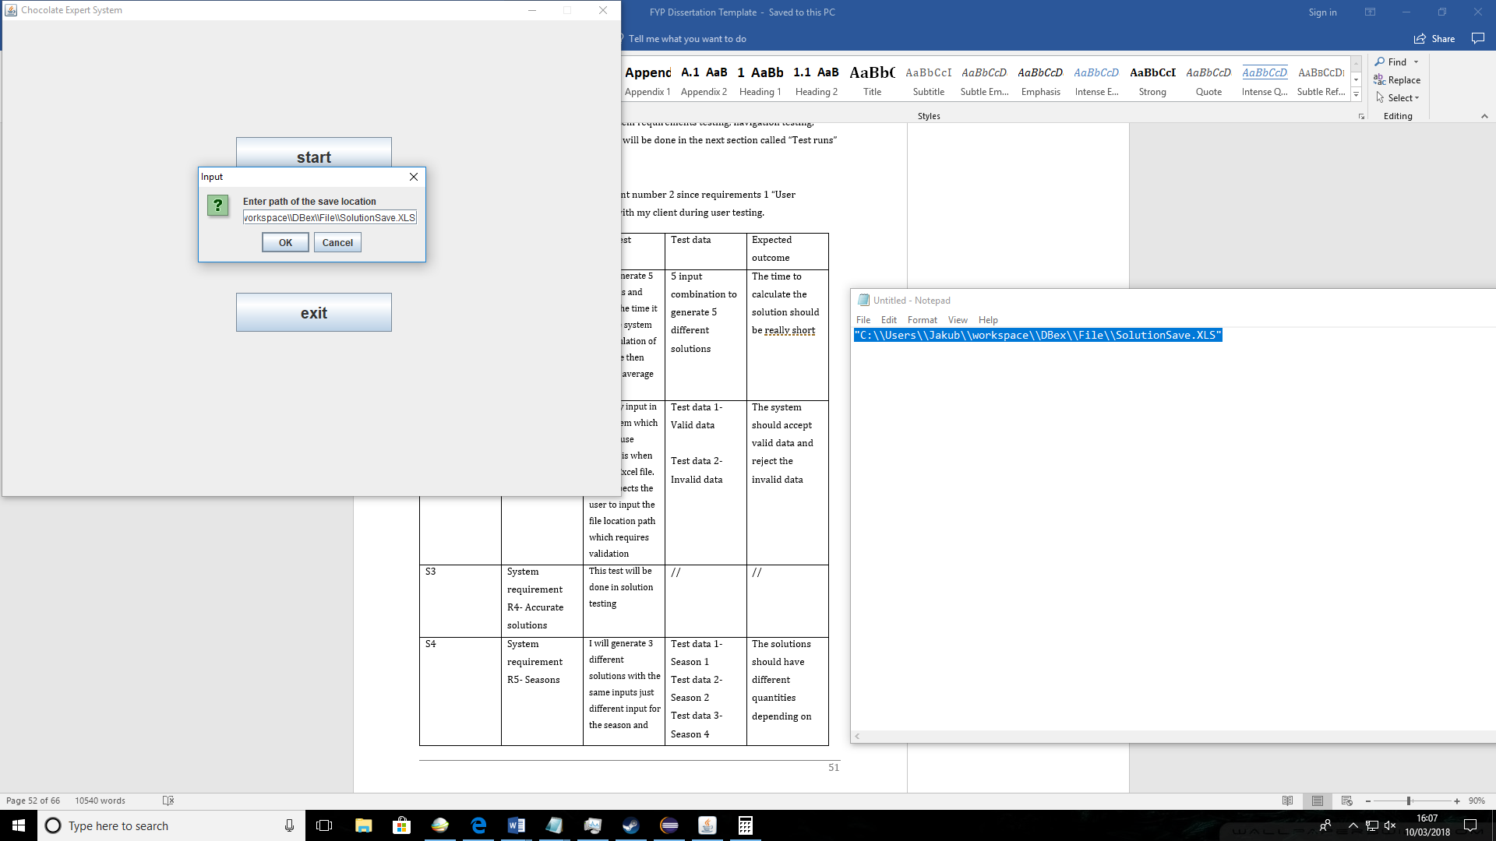

A valid path has been entered.

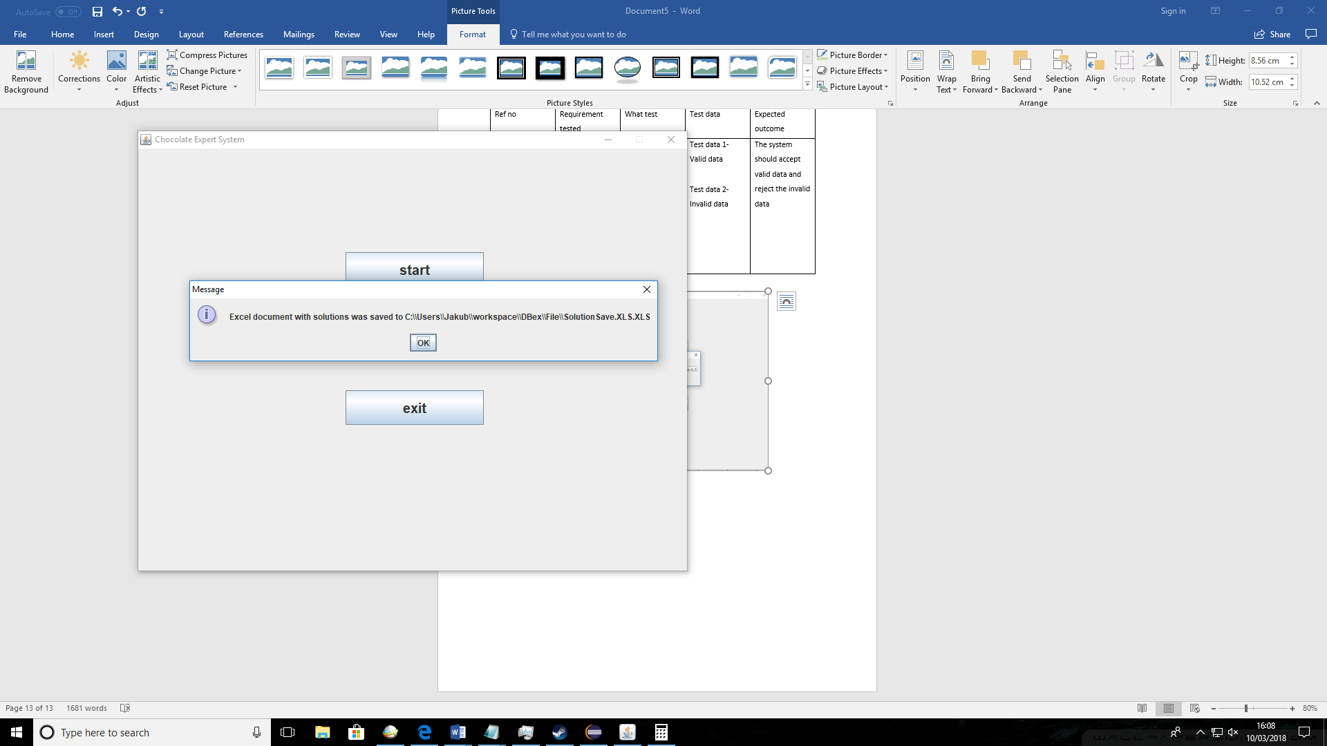

The path was accepted by the system and the Excel file was saved to that location.

Invalid test data

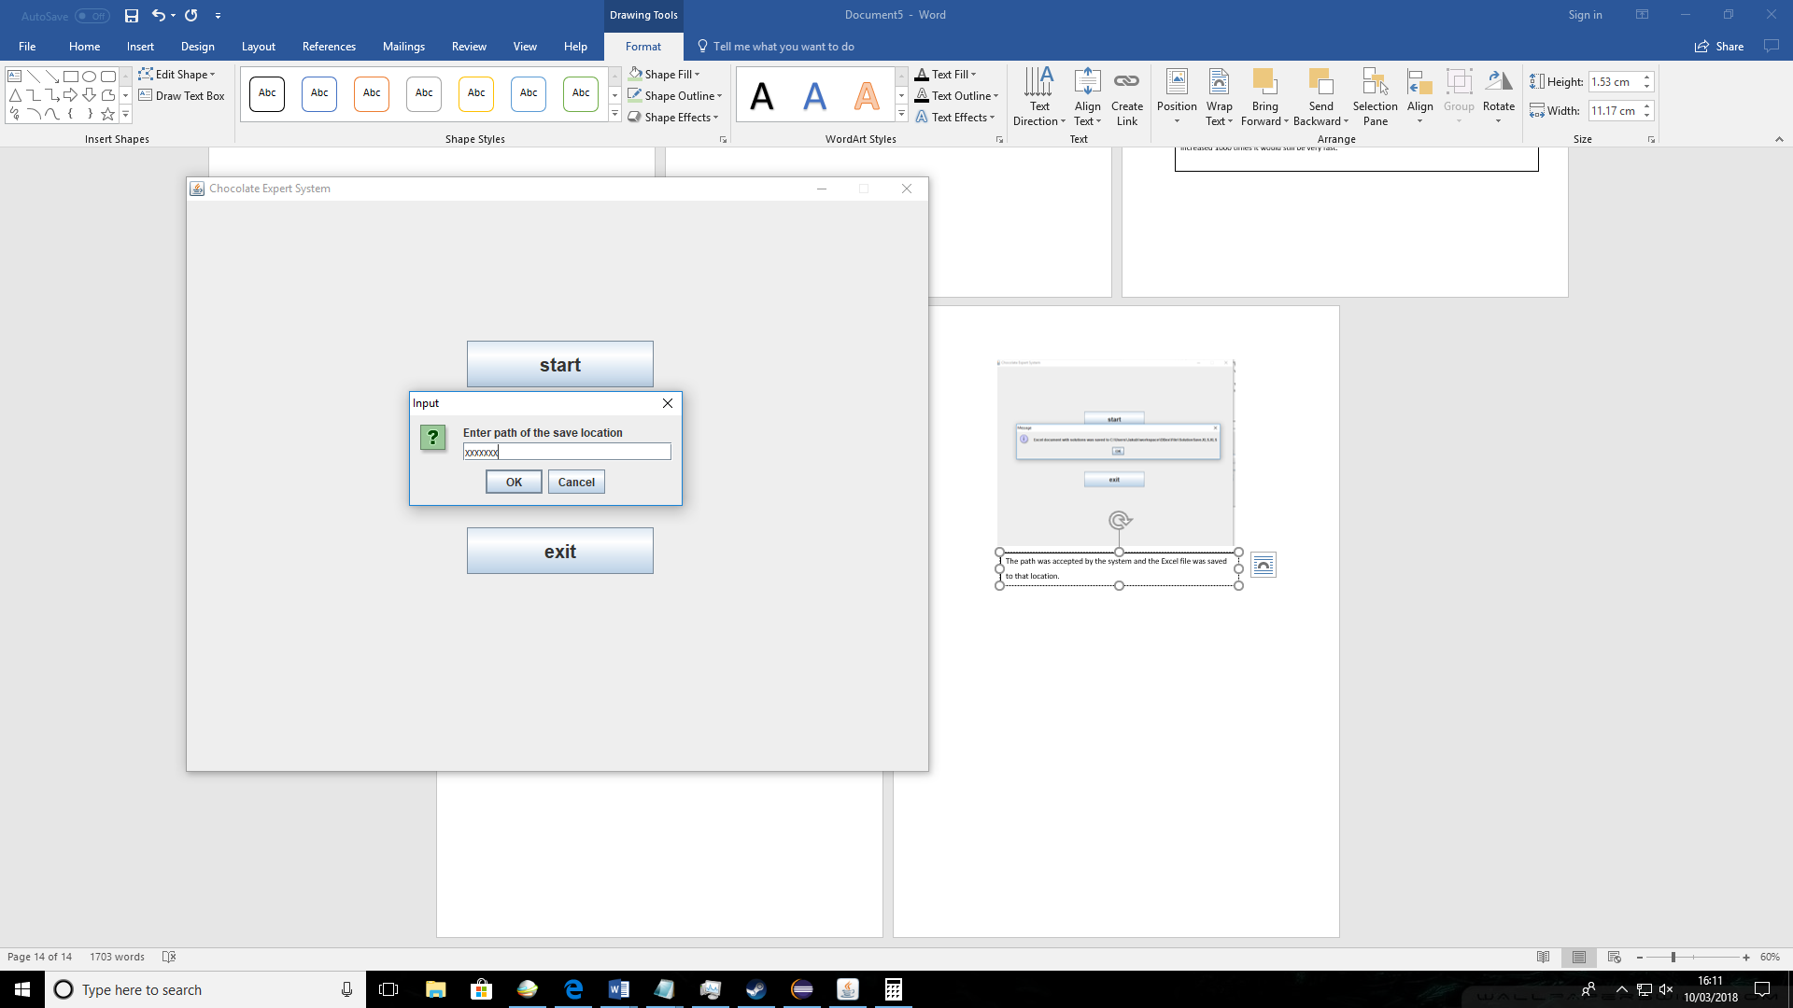

Invalid data path was entered

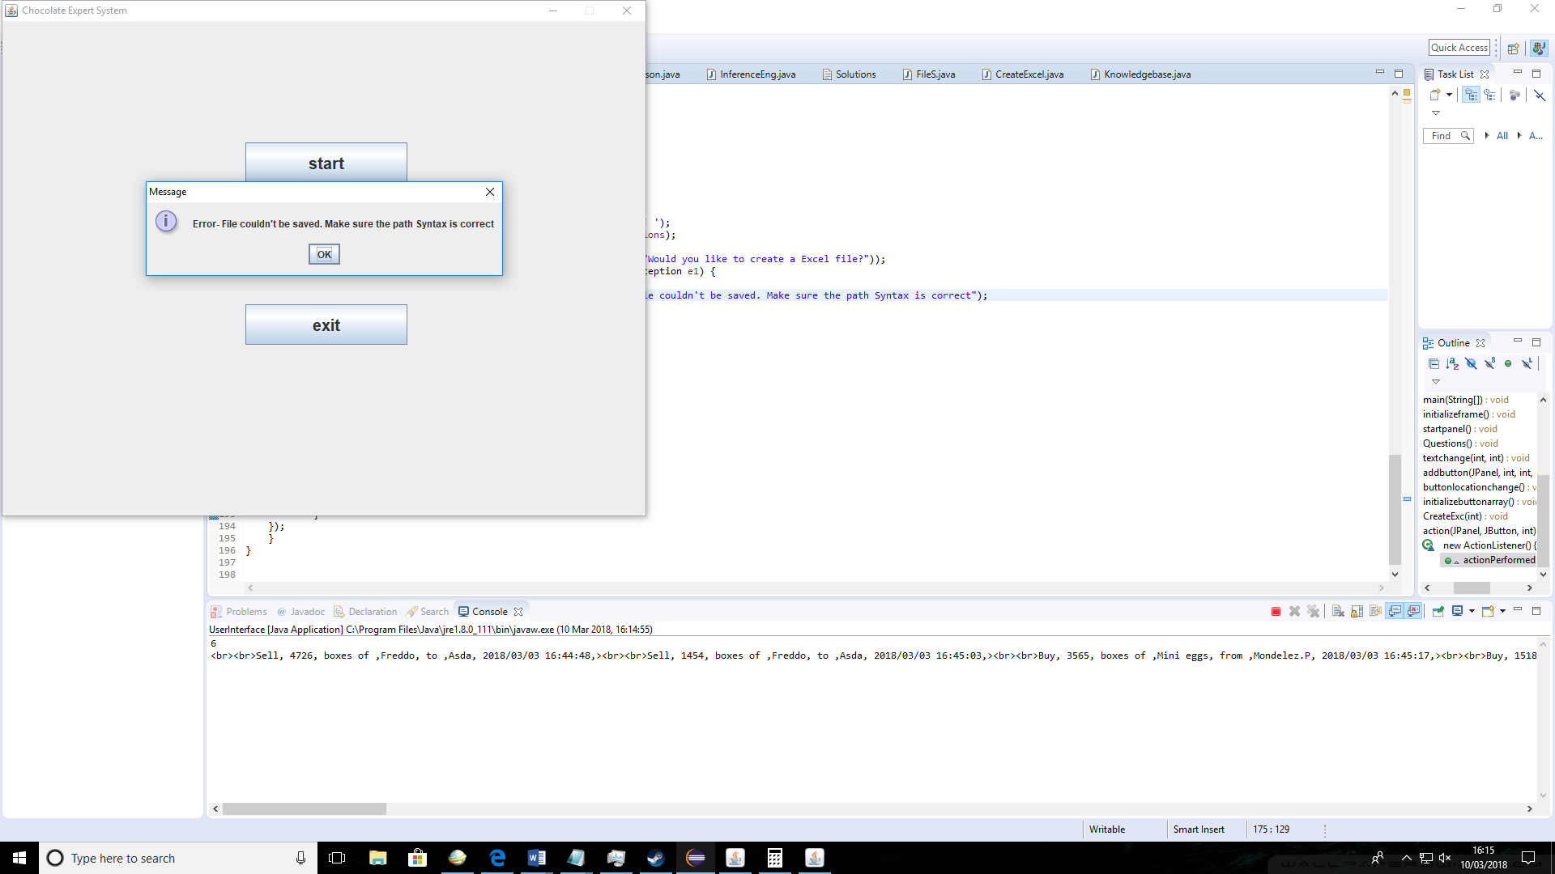

The system didn’t accept the data and error message was displayed

|  |  |  |  |  |  |  |  |  |  |  |  |  |  |  |
| --- | --- | --- | --- | --- | --- | --- | --- | --- | --- | --- | --- | --- | --- | --- |
| |  |  |  |  |  |  | | --- | --- | --- | --- | --- | --- | | Ref no | Requirement tested | What test | Test data | Expected outcome | Actual outcome | | S4 | System requirement R5- Seasons | I will generate 3 different solutions with the same inputs just different input for the season and see how that effects the solution outcome | Test data 1- Season 1  Test data 2- Season 2  Test data 3- Season 4 | The solutions should have different quantities depending on the season popularity | The results show how seasons effect the final solution. From the test you can see that season 4 is the most popular since solution suggested to buy more products. | |  |  |
|  |  |  |

Solution 1

Input combination- Buy/Mini eggs/Low/ Season 1

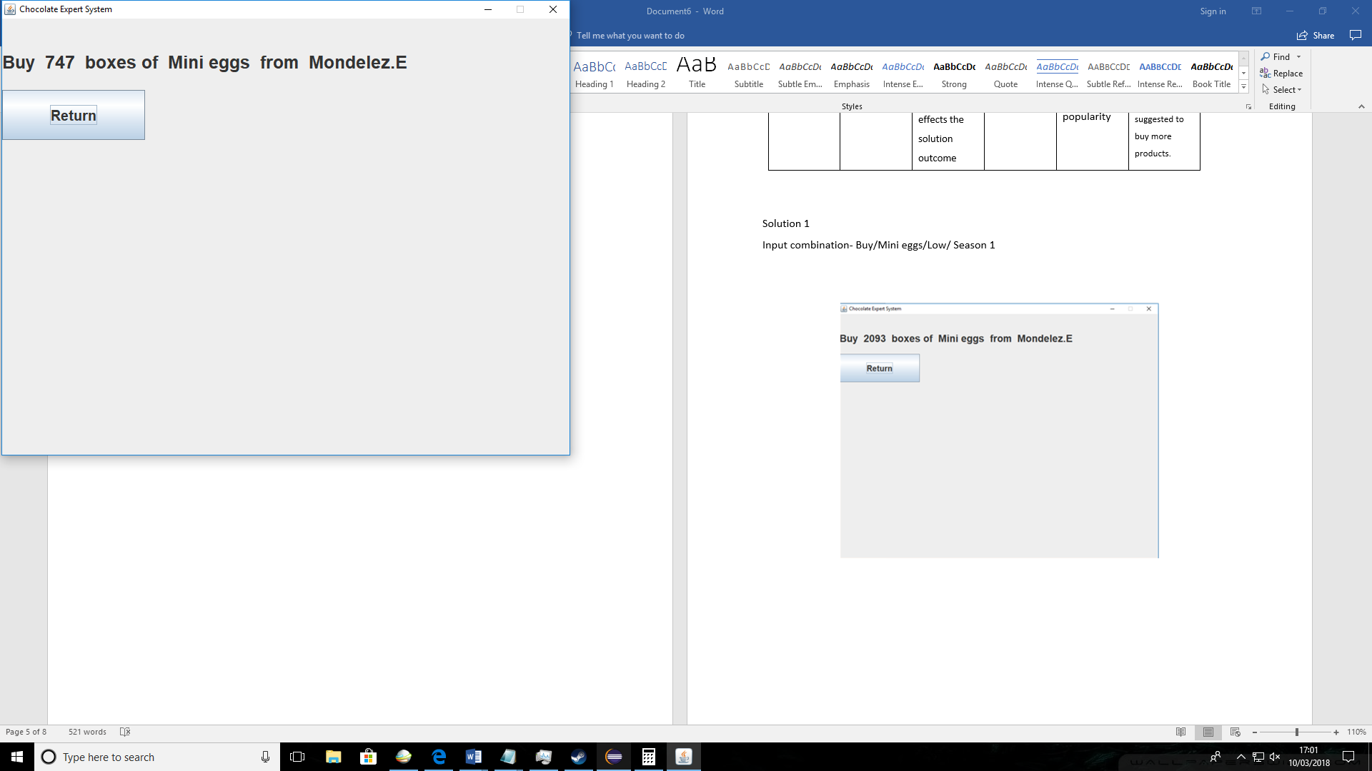

Solution 2

Input combination- Buy/Mini eggs/Low/ Season 2

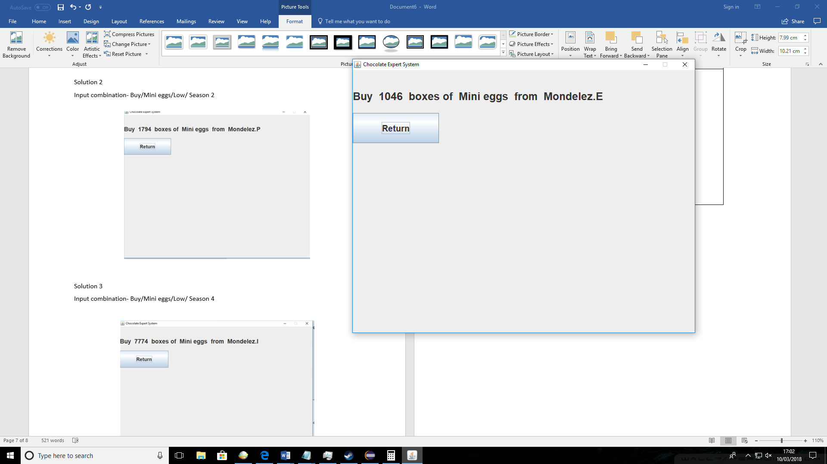

Solution 3

Input combination- Buy/Mini eggs/Low/ Season 4

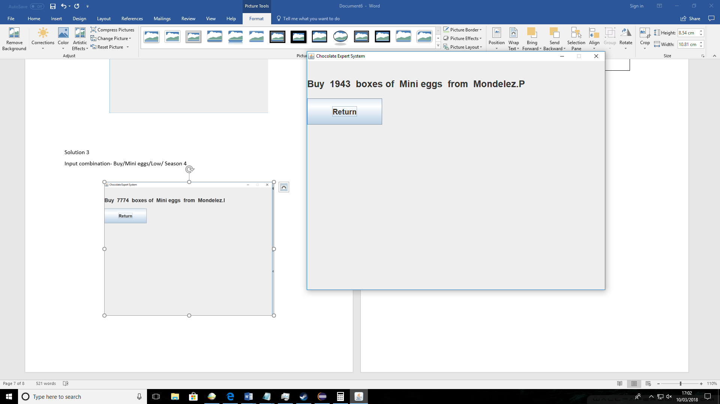

Solution 1

Input combination- Buy/Mini eggs/Low/ Season 1



|  |  |  |  |  |  |  |  |  |  |  |  |  |  |  |
| --- | --- | --- | --- | --- | --- | --- | --- | --- | --- | --- | --- | --- | --- | --- |
| |  |  |  |  |  |  | | --- | --- | --- | --- | --- | --- | | Ref no | Requirement tested | What test | Test data | Expected outcome | Actual outcome | | S5 | System requirement R6- Product Popularity | I will generate 3 different solutions with the same inputs just different input for the product and see how the product popularity effects the solution outcome | Test data 1- “Mini eggs”  Test data 2- “Freddo”  Test data 3- “Fudge” | The solutions should have different quantities depending on the product popularity | From the test result you can see the most popular product “Fudge” had the most quantity to order in solution. All solutions had different quantities | |  |  |
|  |  |  |

Solution 2

Input combination- Buy/Freddo/Low/ Season 1

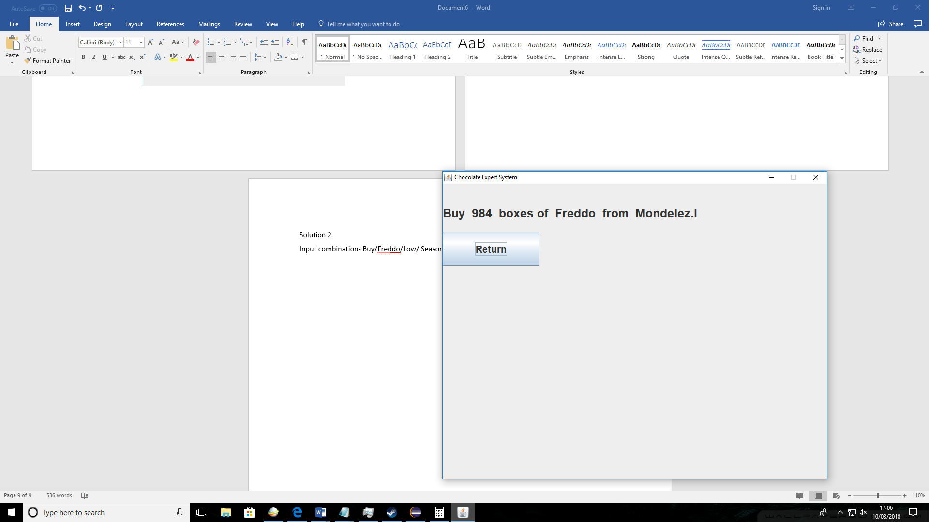

Solution 3

Input combination- Buy/Fudge/Low/ Season 1

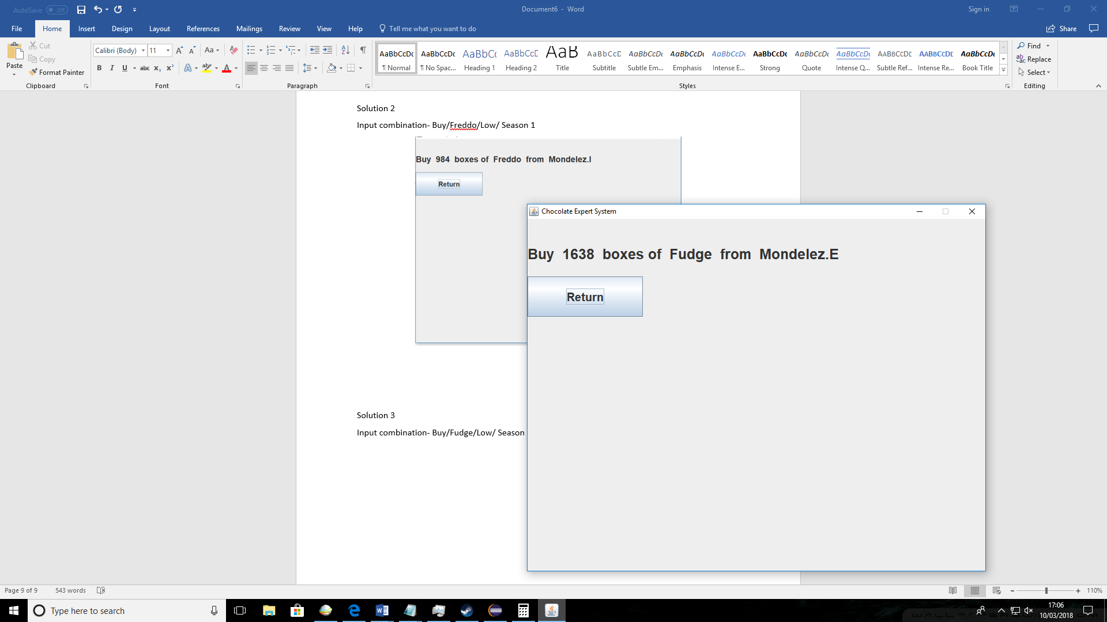

|  |  |  |  |  |  |  |  |  |  |  |  |  |
| --- | --- | --- | --- | --- | --- | --- | --- | --- | --- | --- | --- | --- |
| |  |  |  |  |  |  | | --- | --- | --- | --- | --- | --- | | Ref no | Requirement tested | What test | Test data | Expected outcome | Actual outcome | | S6 | System requirement R7- Product Quantity | I will generate 3 different solutions with the same inputs just different input for the product quantity and see how that effects the solution outcome | Test data 1- “Low”  Test data 2- “Medium”  Test data 3- “Very high” | The solutions should have different quantities depending on the product Quantity | All the solution quantities were different. The fewer the current product quantity the lower solution quantity is sine less products should be sold in that case. | |
|  |

Input combination- Buy/Mini eggs/Low/ Season 1



Solution 2

Input combination- Buy/Mini eggs/Medium/ Season 1

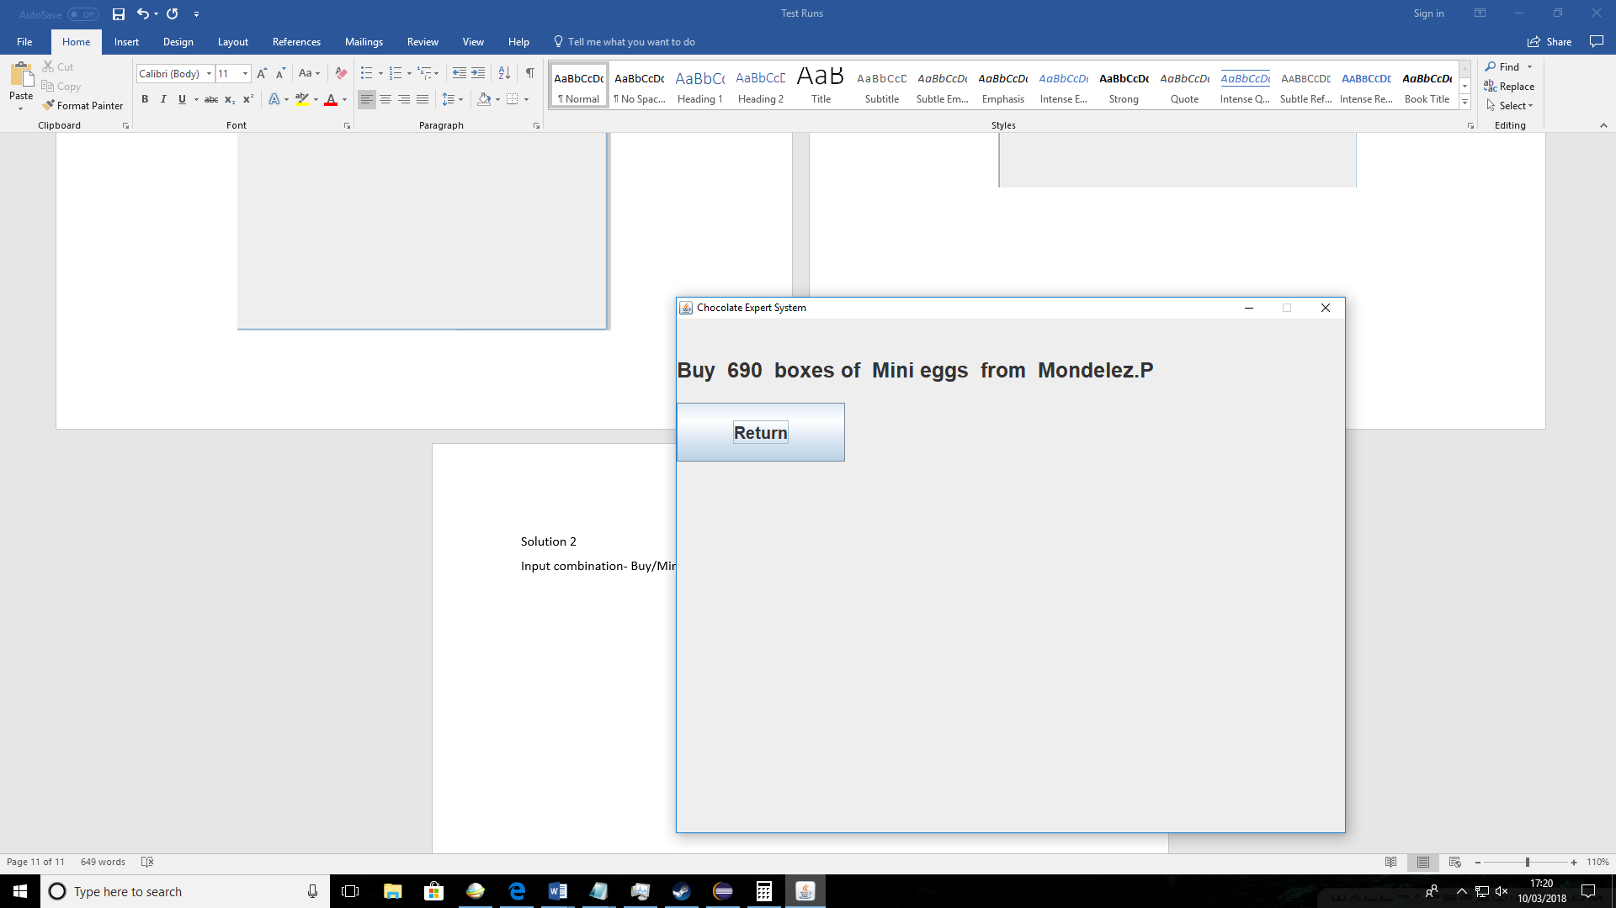

Solution 3

Input combination- Buy/Mini eggs/Very High/ Season 1

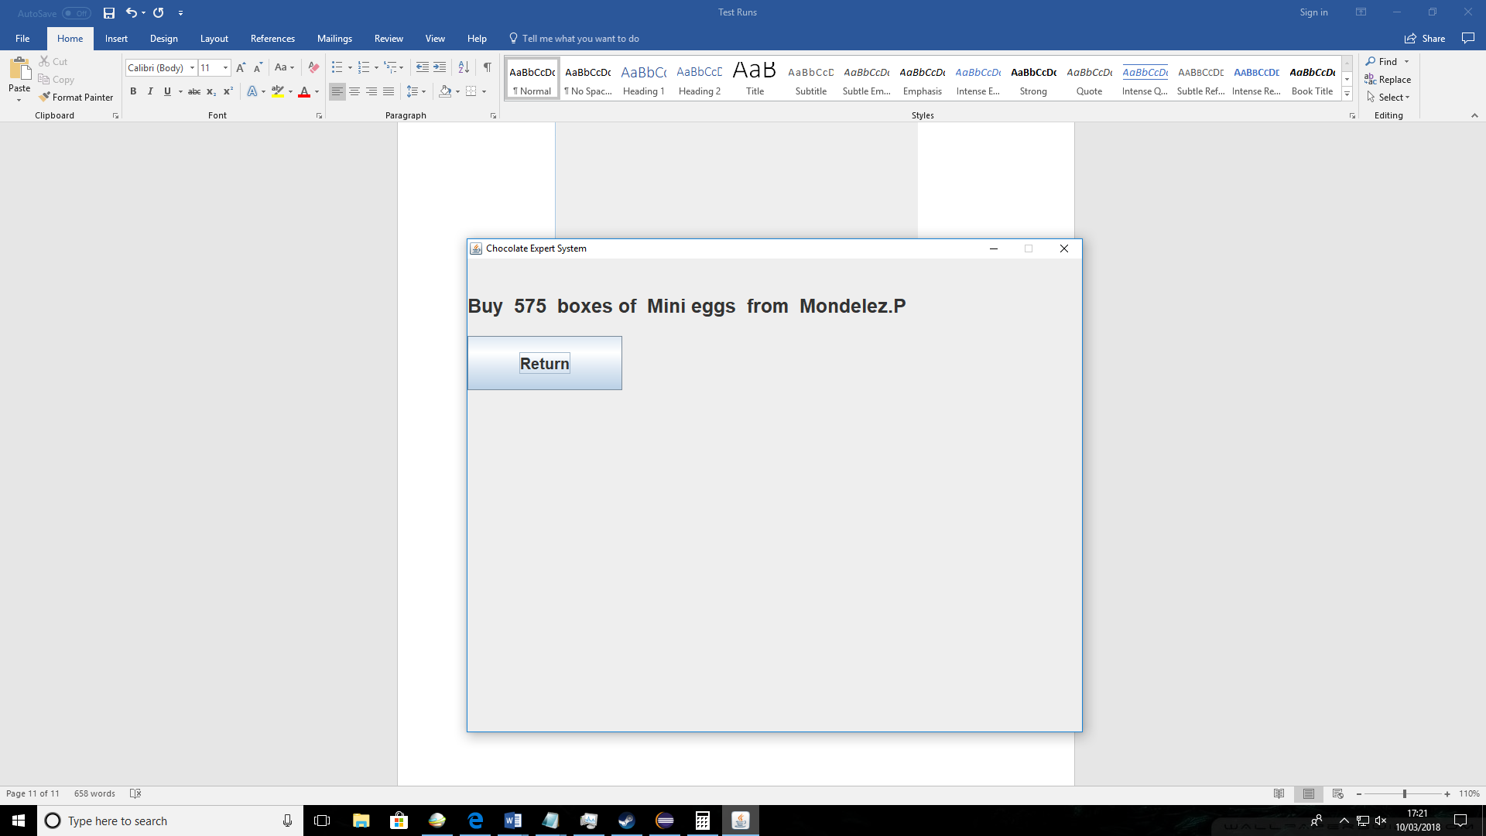

|  |  |  |  |  |  |  |  |  |  |  |  |  |
| --- | --- | --- | --- | --- | --- | --- | --- | --- | --- | --- | --- | --- |
| |  |  |  |  |  |  | | --- | --- | --- | --- | --- | --- | | Ref no | Requirement tested | What test | Test data | Expected outcome | Actual outcome | | S7 | System requirement R8- Finding customer and supplier | I will generate 4 solution combinations. 2 when buying products from supplier and when selling products to customer. This will test if the system can pick appropriate suppliers and customers with the solution. | Test data 1- Buy “Mini eggs”  Test data 2- Buy “Freddo”  Test data 3- Sell “Fudge”  Test data 4- Sell “Freddo” | The system should pick appropriate customer for the products being sold and appropriate supplier when buying the products | For both buying and selling product the system chose relevant suppliers and customers in the solution. | |
|  |

Test data 1 – buying mini eggs

Input combination- Buy/Mini eggs/Low/ Season 1

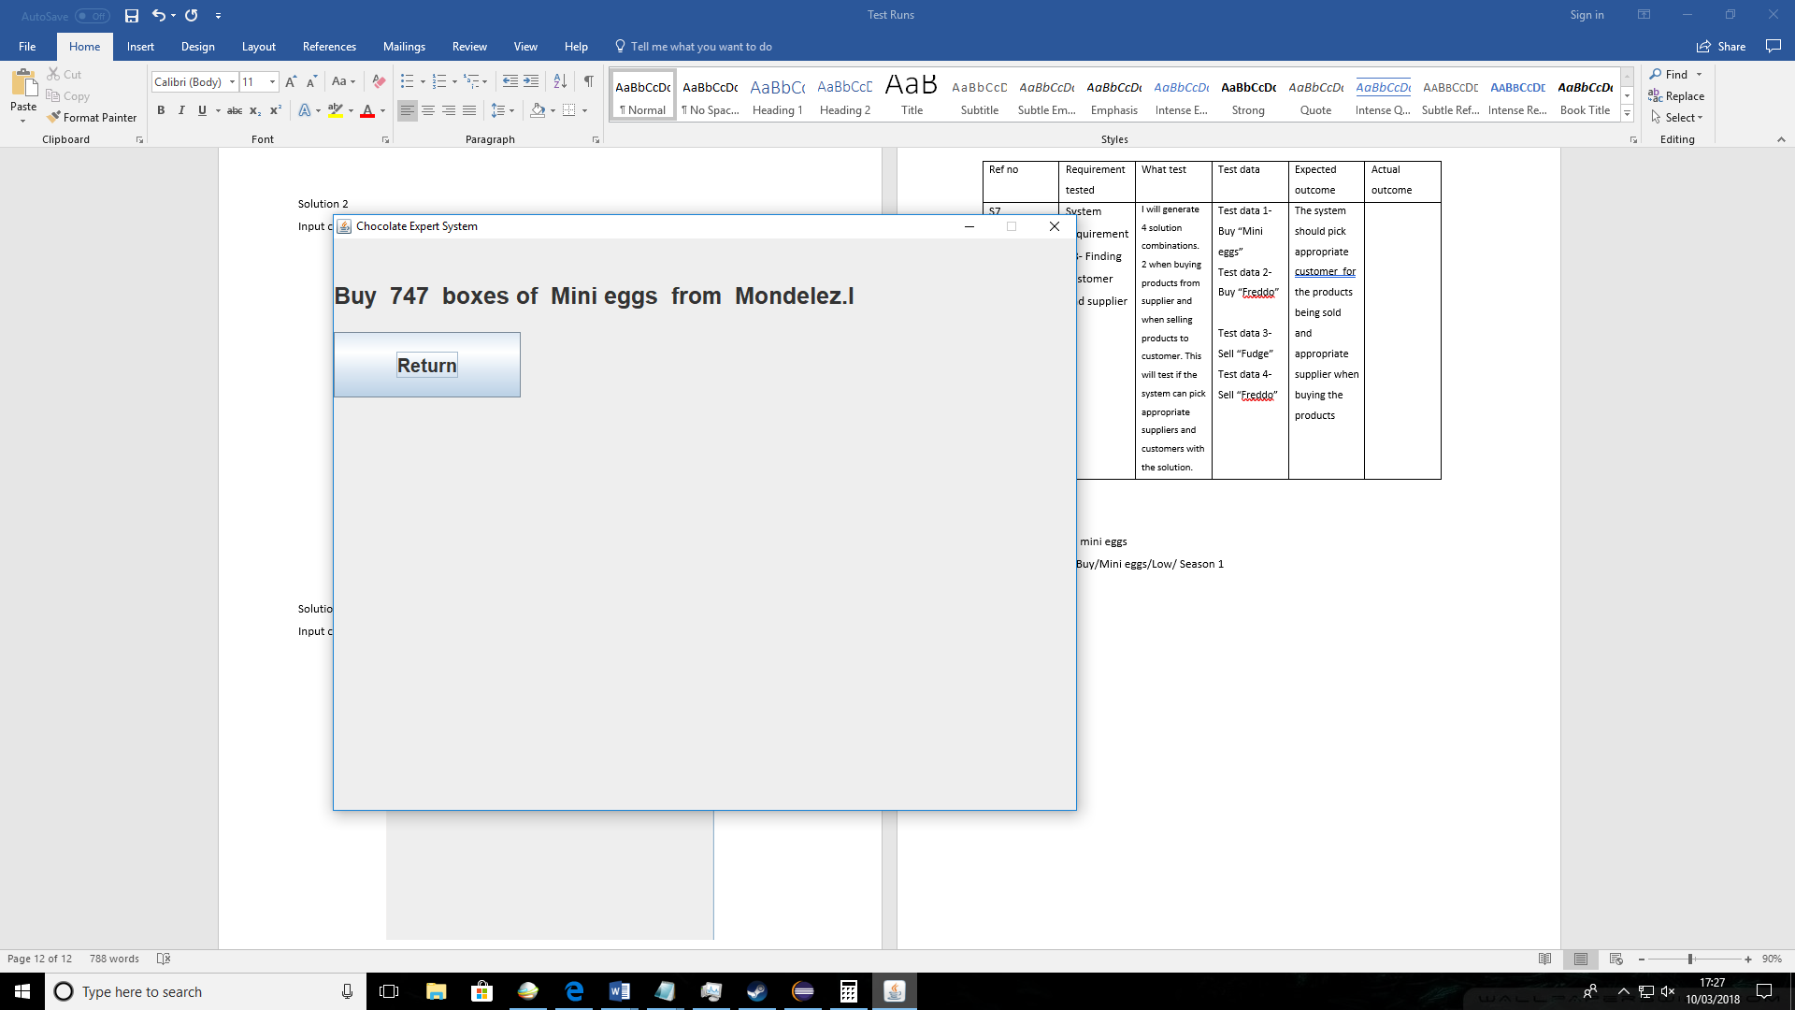

Test data 2 – buying Freddo

Input combination- Buy/Freddo/Low/ Season 1

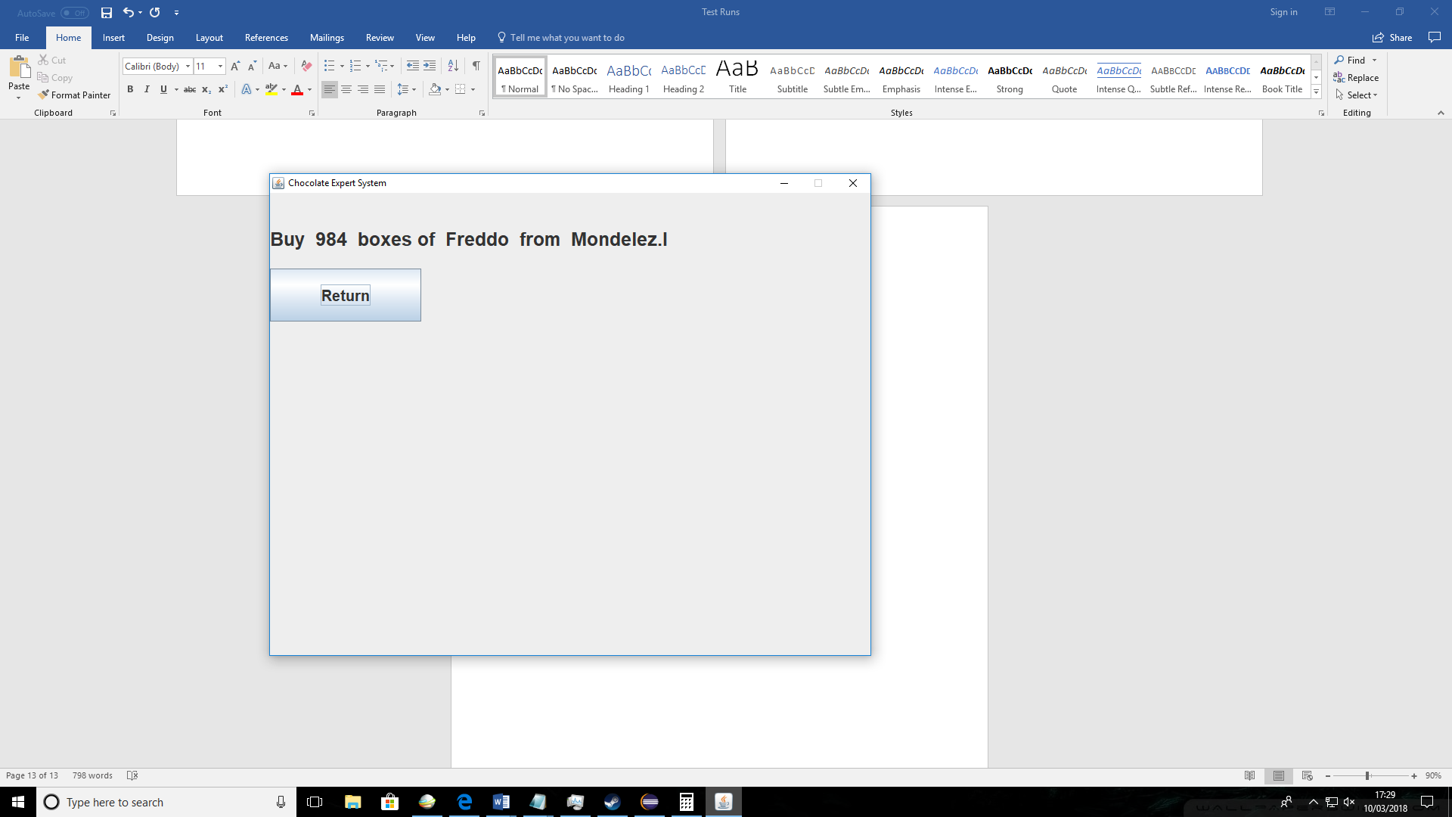

For both mini eggs and Freddos same supplier has been suggested by the system. For mini eggs I know that there is no favourite supplier therefore it was just picked randomly. For Freddos I know that this is their favourite supplier therefore it has been picked.

Test data 3 – Selling Fudge

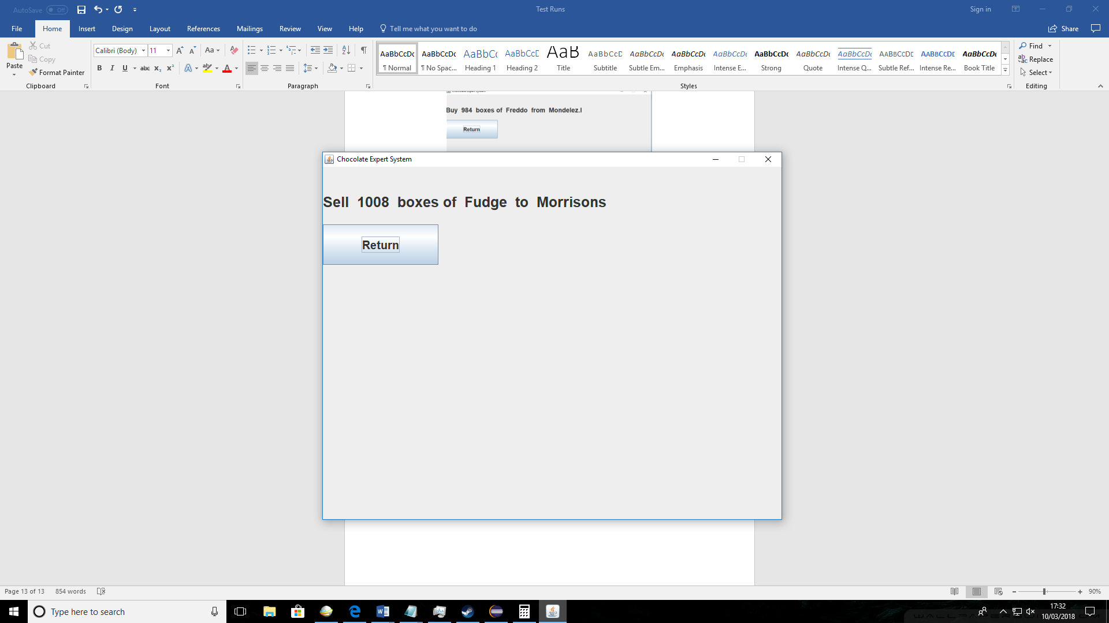Input combination- Sell/Fudge/Low/ Season 1

Test data 4 – Sellng Freddo

Input combination- Sell/Freddo/Low/ Season 1

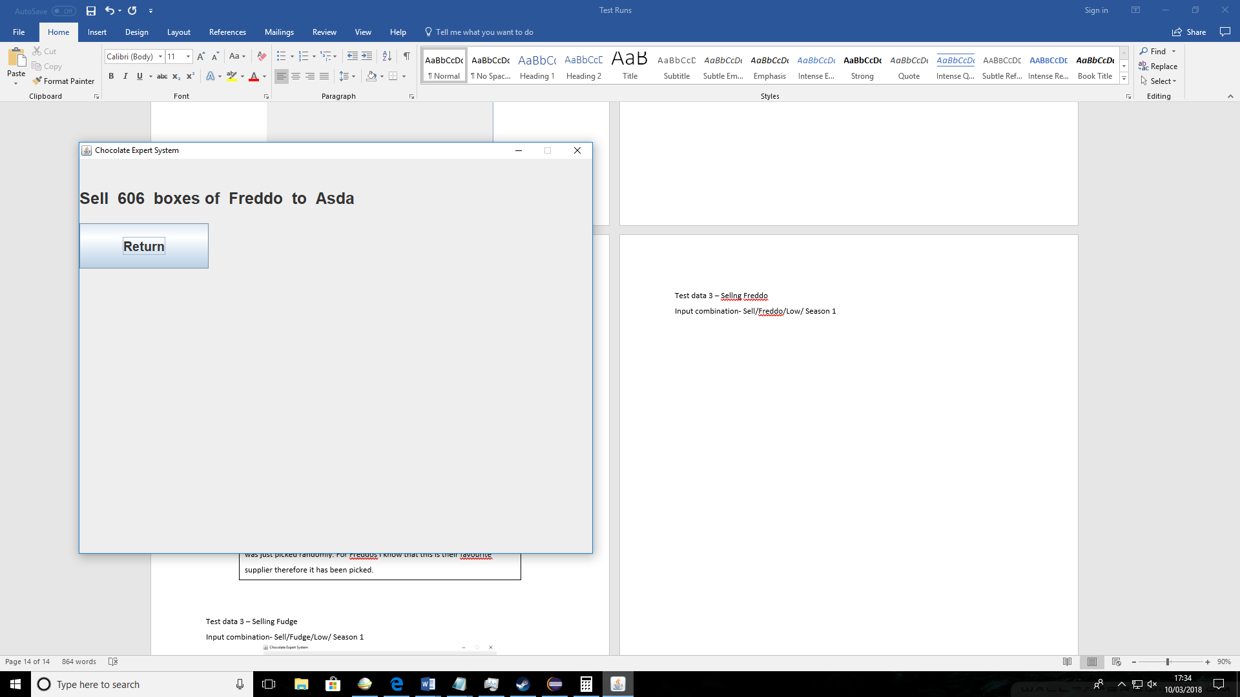

The fudge in test 3 was given a suggestion of customer “Morrisons” I know that this was random since this product doesn’t have a most common customer. Freddo in test 4 was given supplier “Asda” since that is its most common customer.

|  |  |  |  |  |  |  |  |  |  |  |  |  |
| --- | --- | --- | --- | --- | --- | --- | --- | --- | --- | --- | --- | --- |
| |  |  |  |  |  |  | | --- | --- | --- | --- | --- | --- | | Ref no | Requirement tested | What test | Test data | Expected outcome | Actual outcome | | S8 | System requirement R8- Saving solutions to file | I will generate 4 solutions and then use “View solutions” option to see if they have saved | Test data 1- Buy “Feddo”  Test data 2- Sell “Mini eggs”  Test data 3- Sell “Fudge”  Test data 4- Sell “Freddo” | The solution to the inputs should be saved in the file and I should be able to view them in the system | The solutions viewed by the system matched the solutions saved in screenshots. | |
|  |

Save solution 1

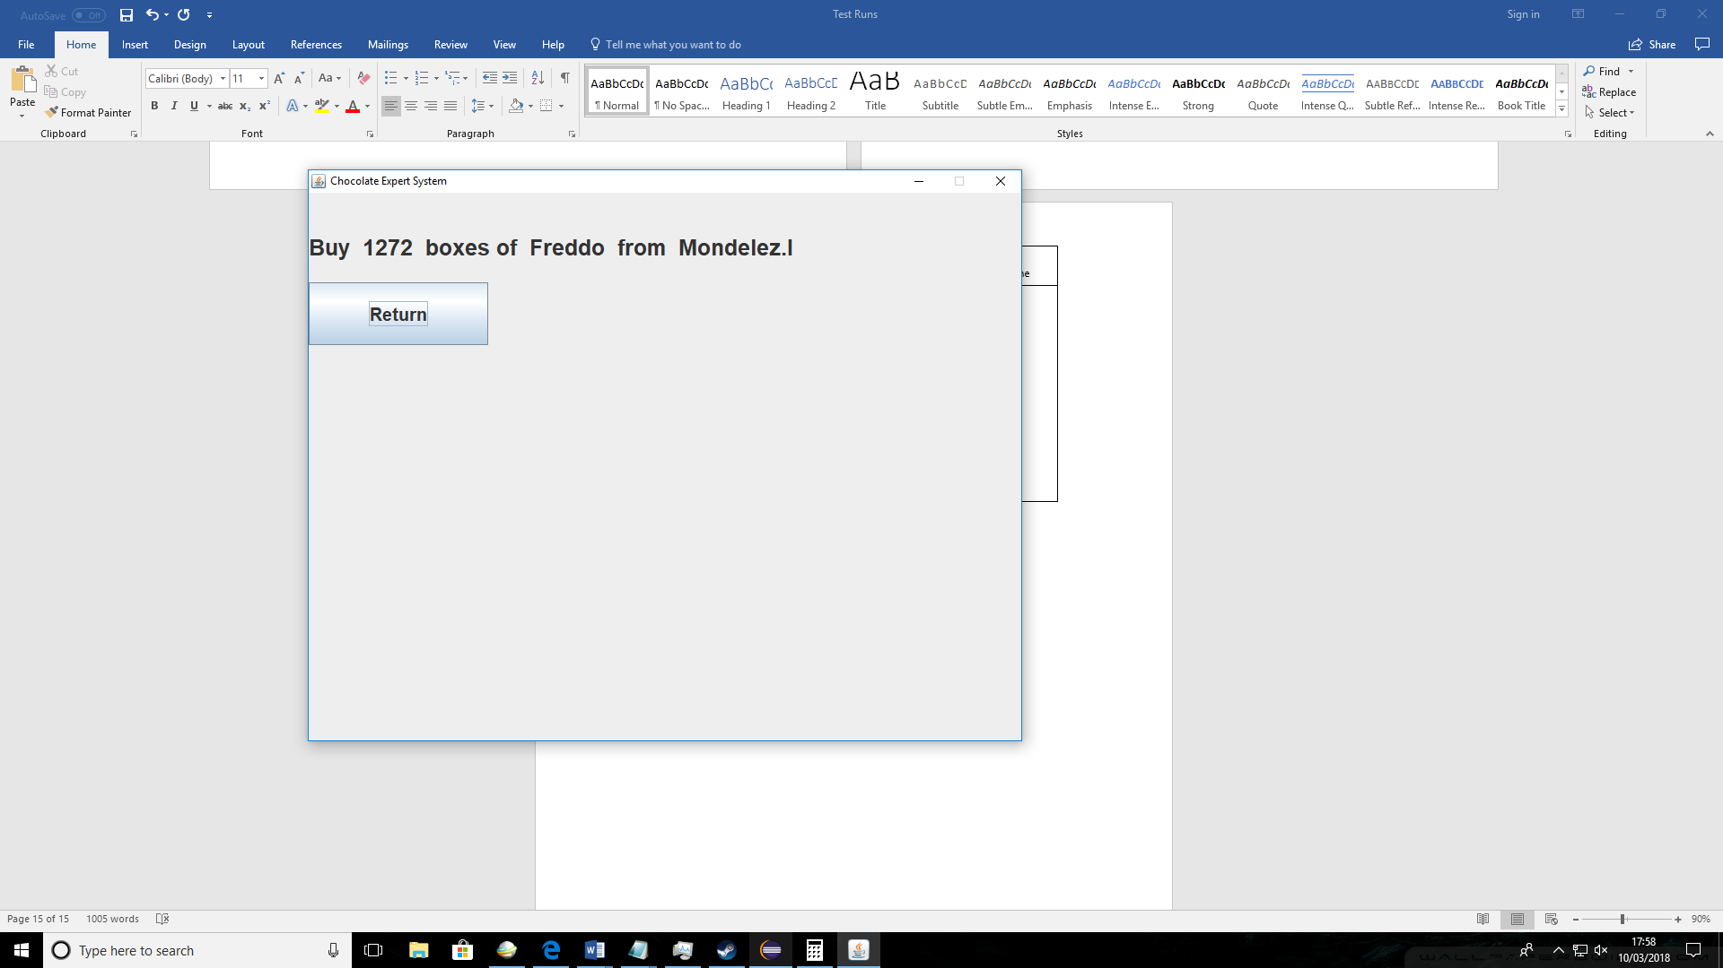

Save solution 2

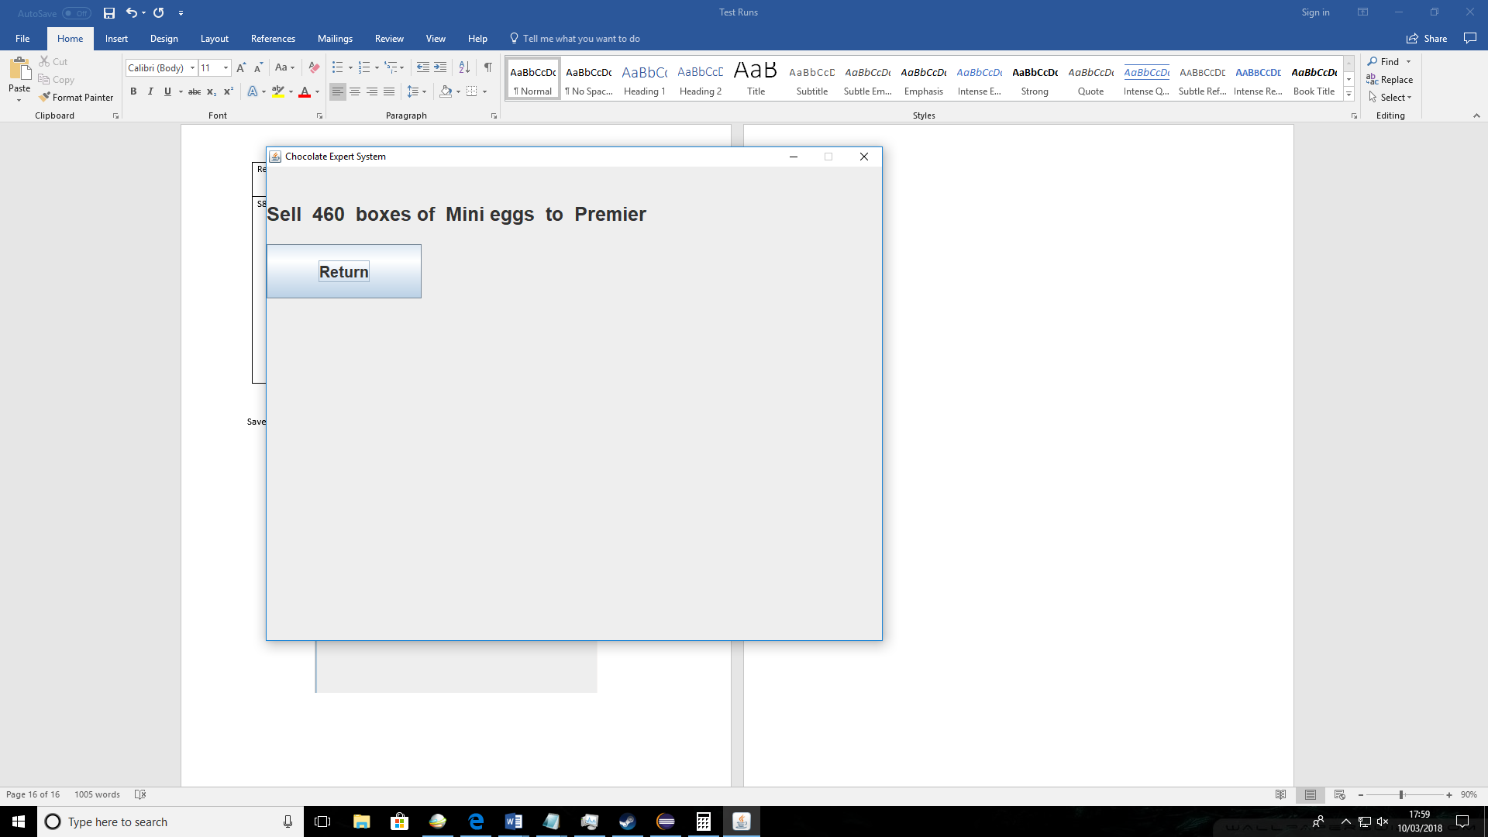

Save solution 3

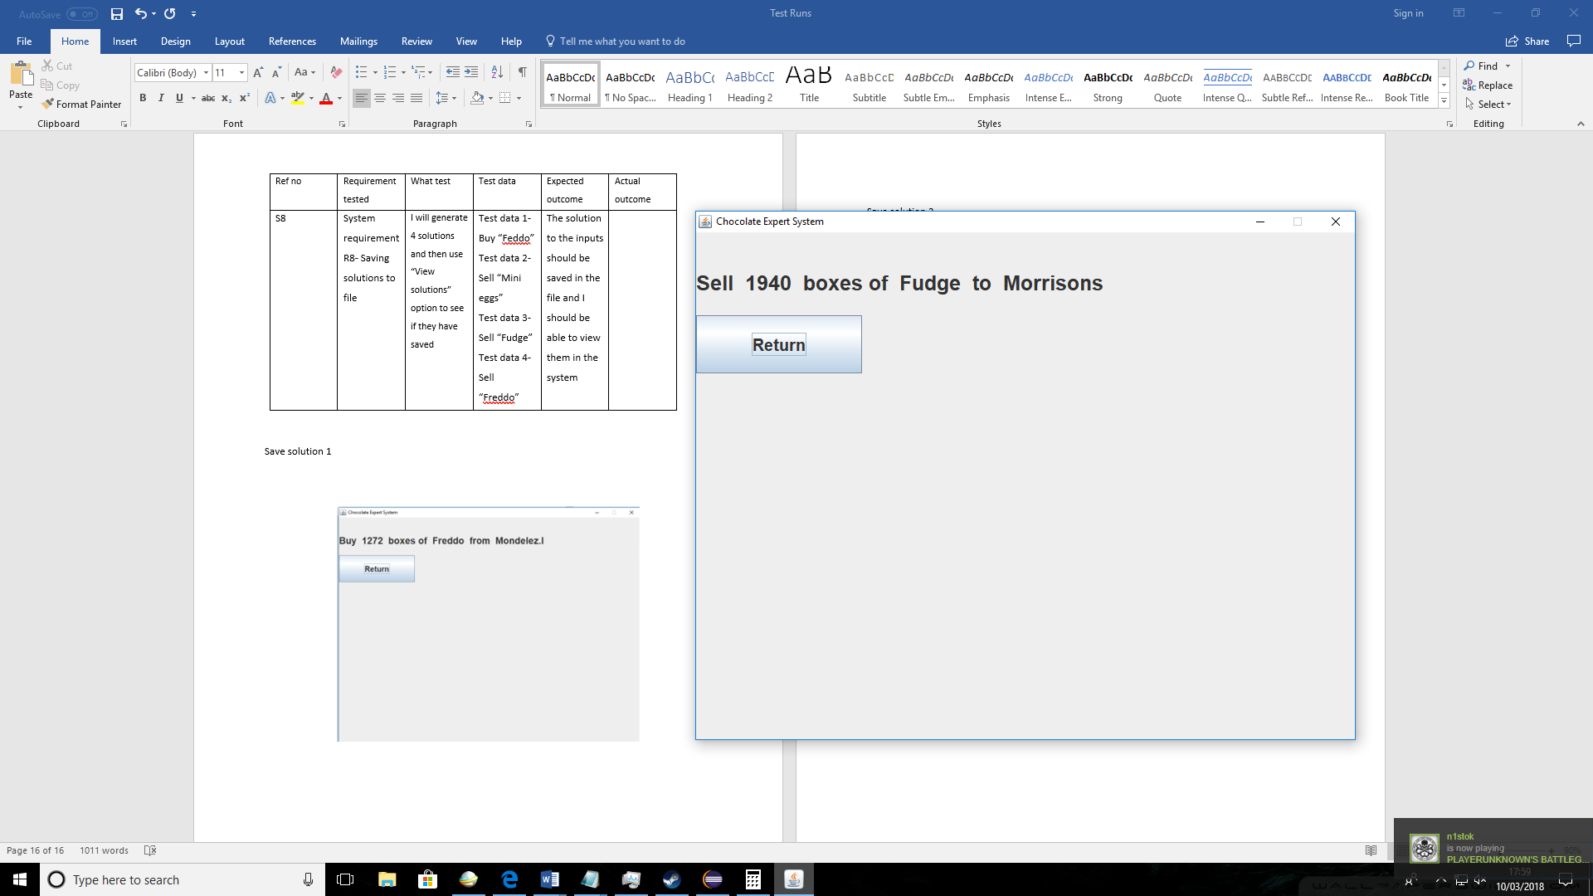

Save solution 4

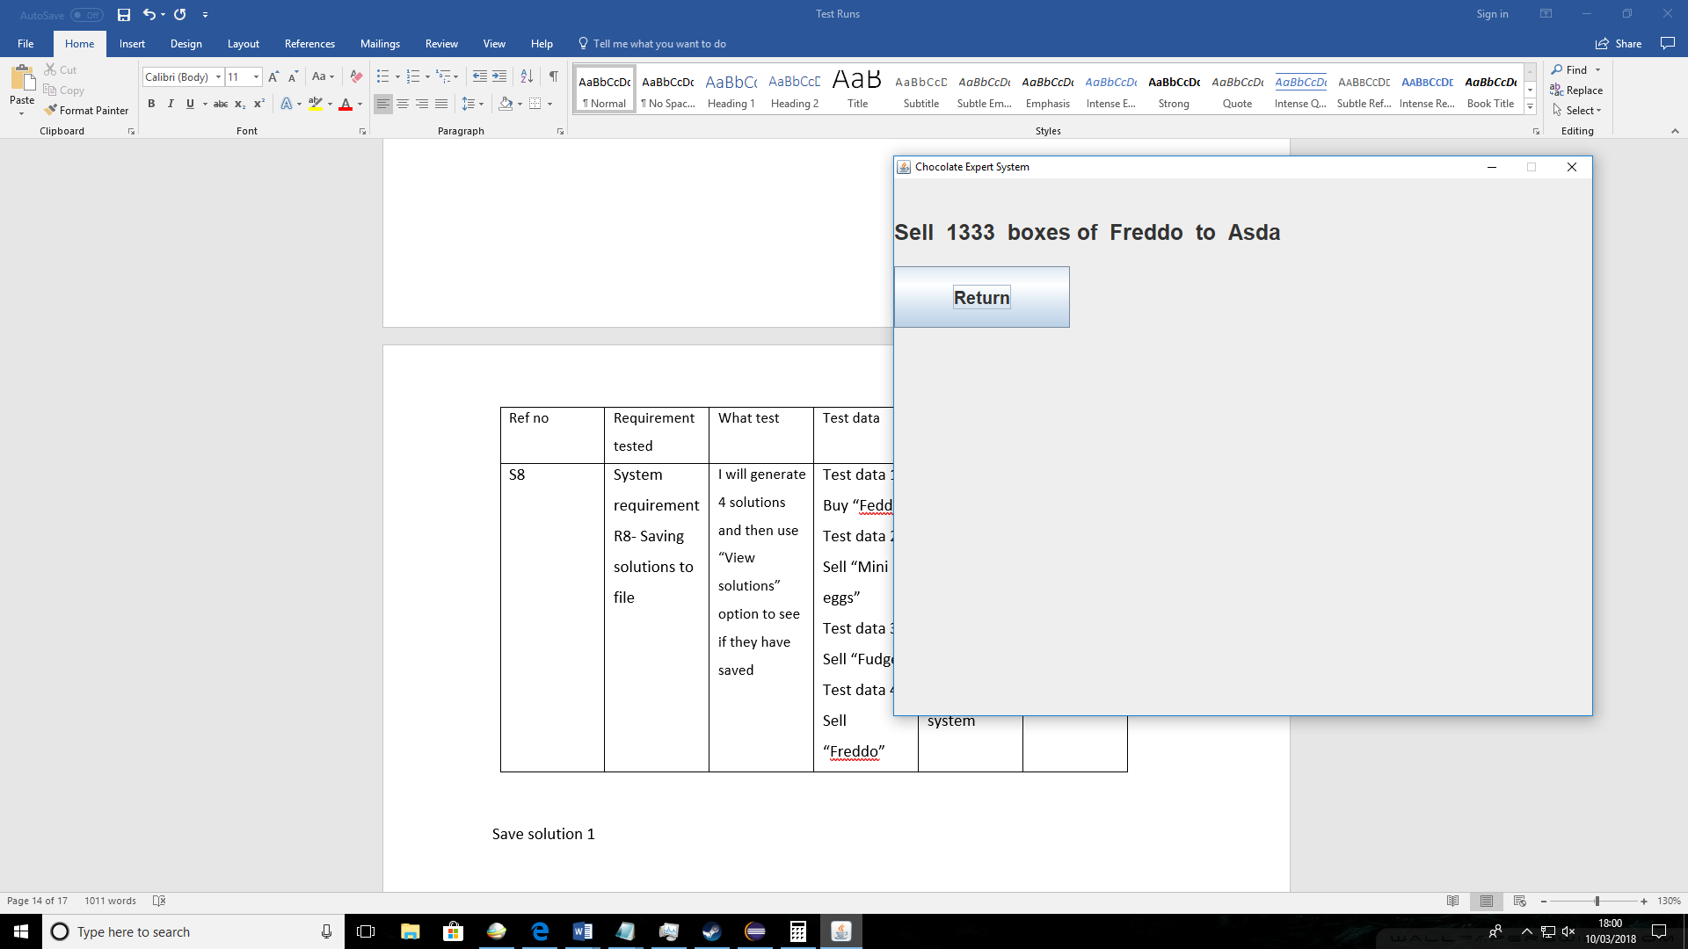

Viewing solutions

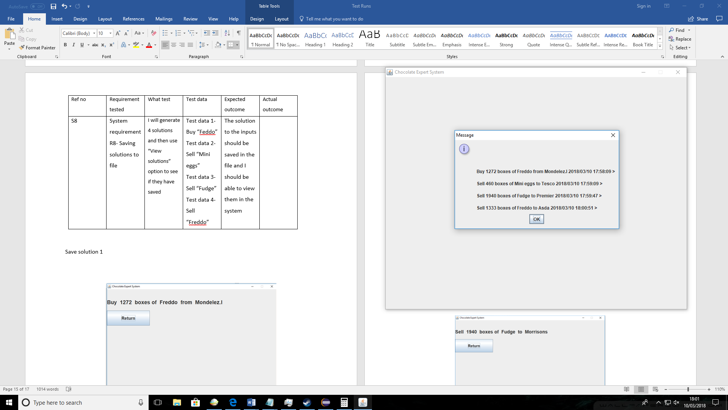

|  |  |  |  |  |  |  |  |  |  |  |  |  |
| --- | --- | --- | --- | --- | --- | --- | --- | --- | --- | --- | --- | --- |
| |  |  |  |  |  |  | | --- | --- | --- | --- | --- | --- | | Ref no | Navigation tested | What test | Test data | Expected outcome | Actual outcome | | N1 | Start Button & question buttons | I will press start and check if it takes me to the questions. After that I will use the answer buttons until the solution is displayed | Start and question buttons | The start button should take the user to first question. When user picks the answer for a question the next question should display until the last question which after a solution should display |  | |
|  |

First scenario- Generating solution

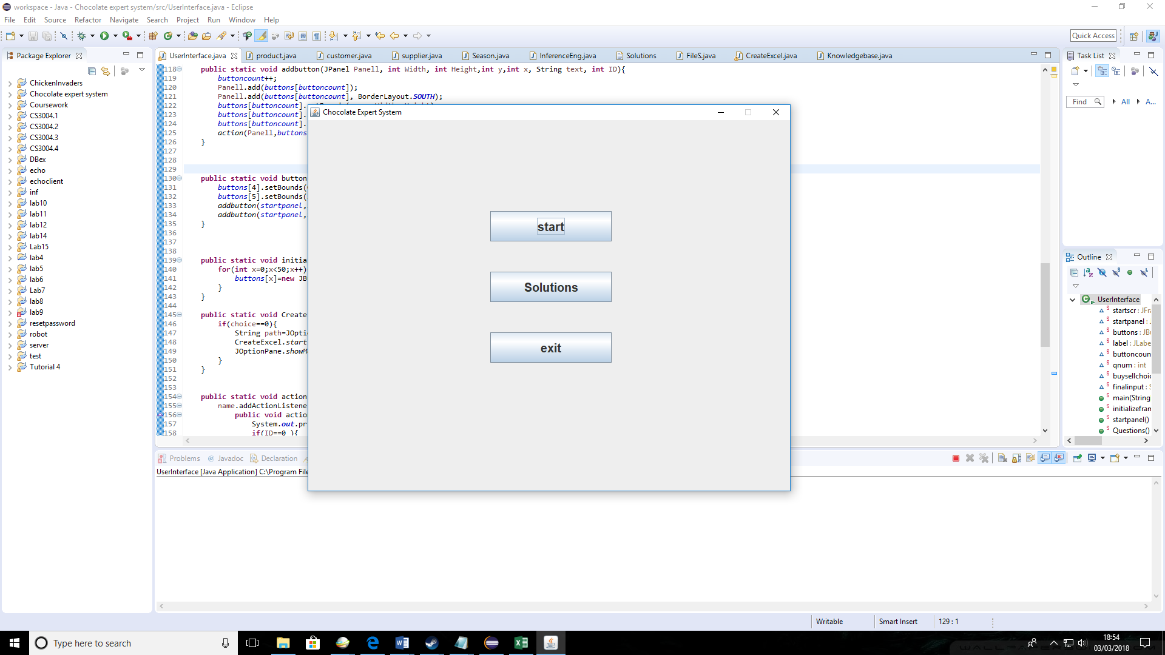

Input - Start button

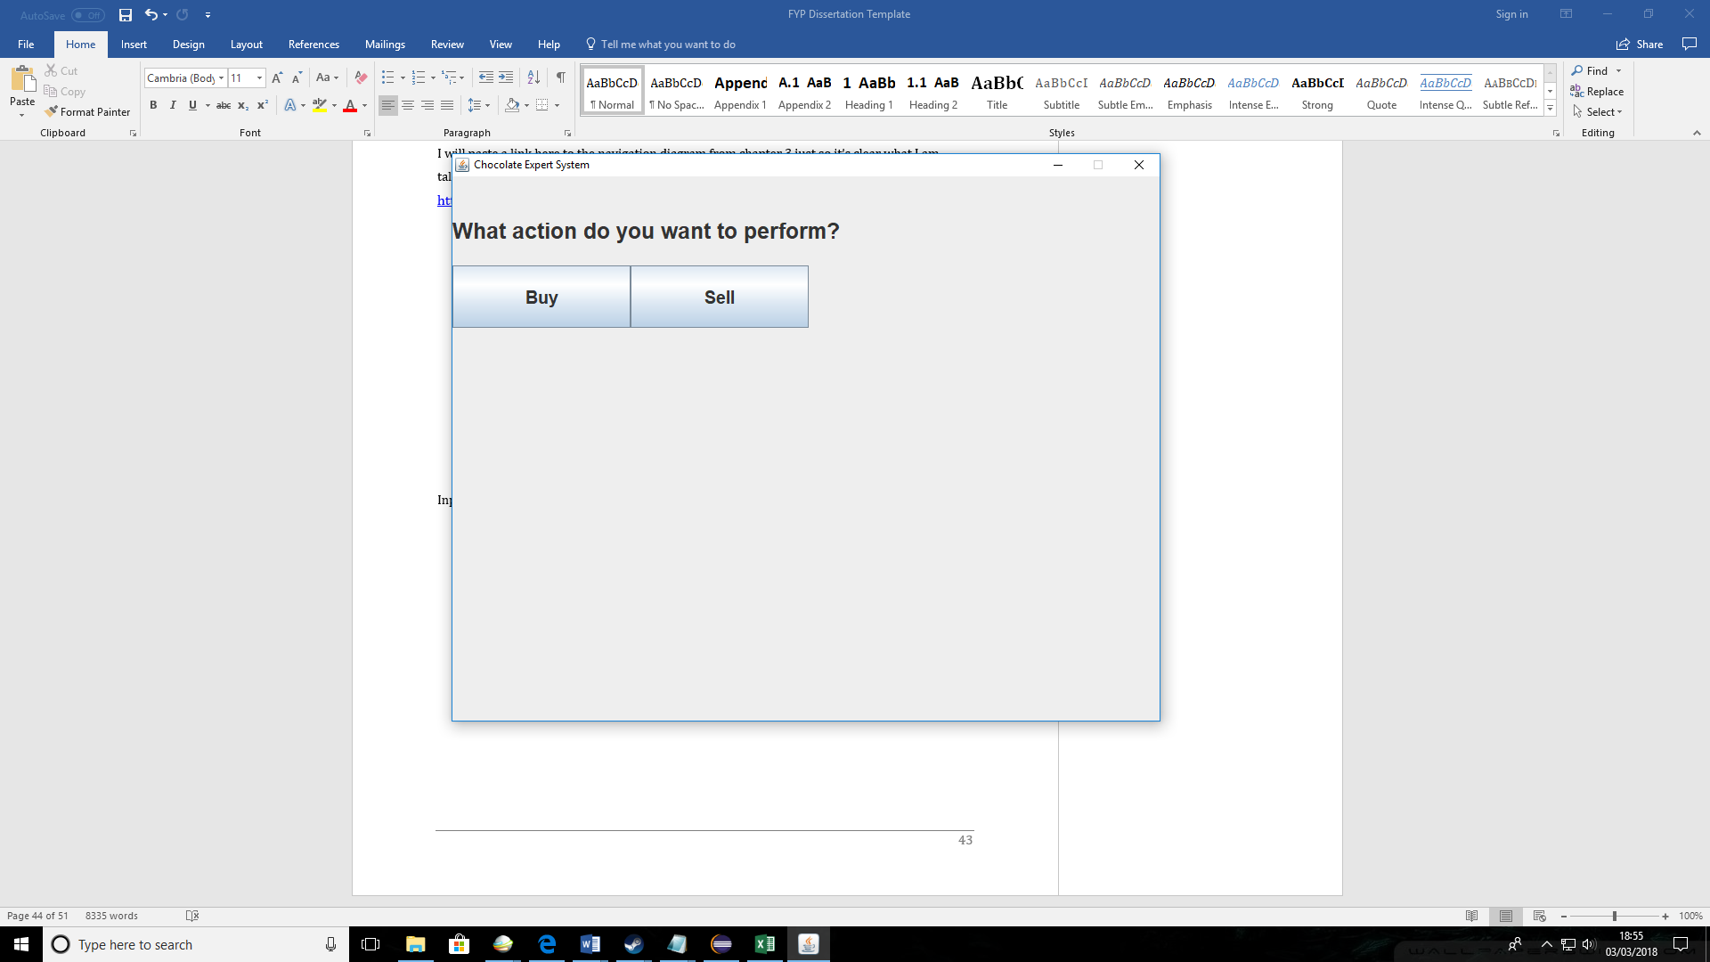

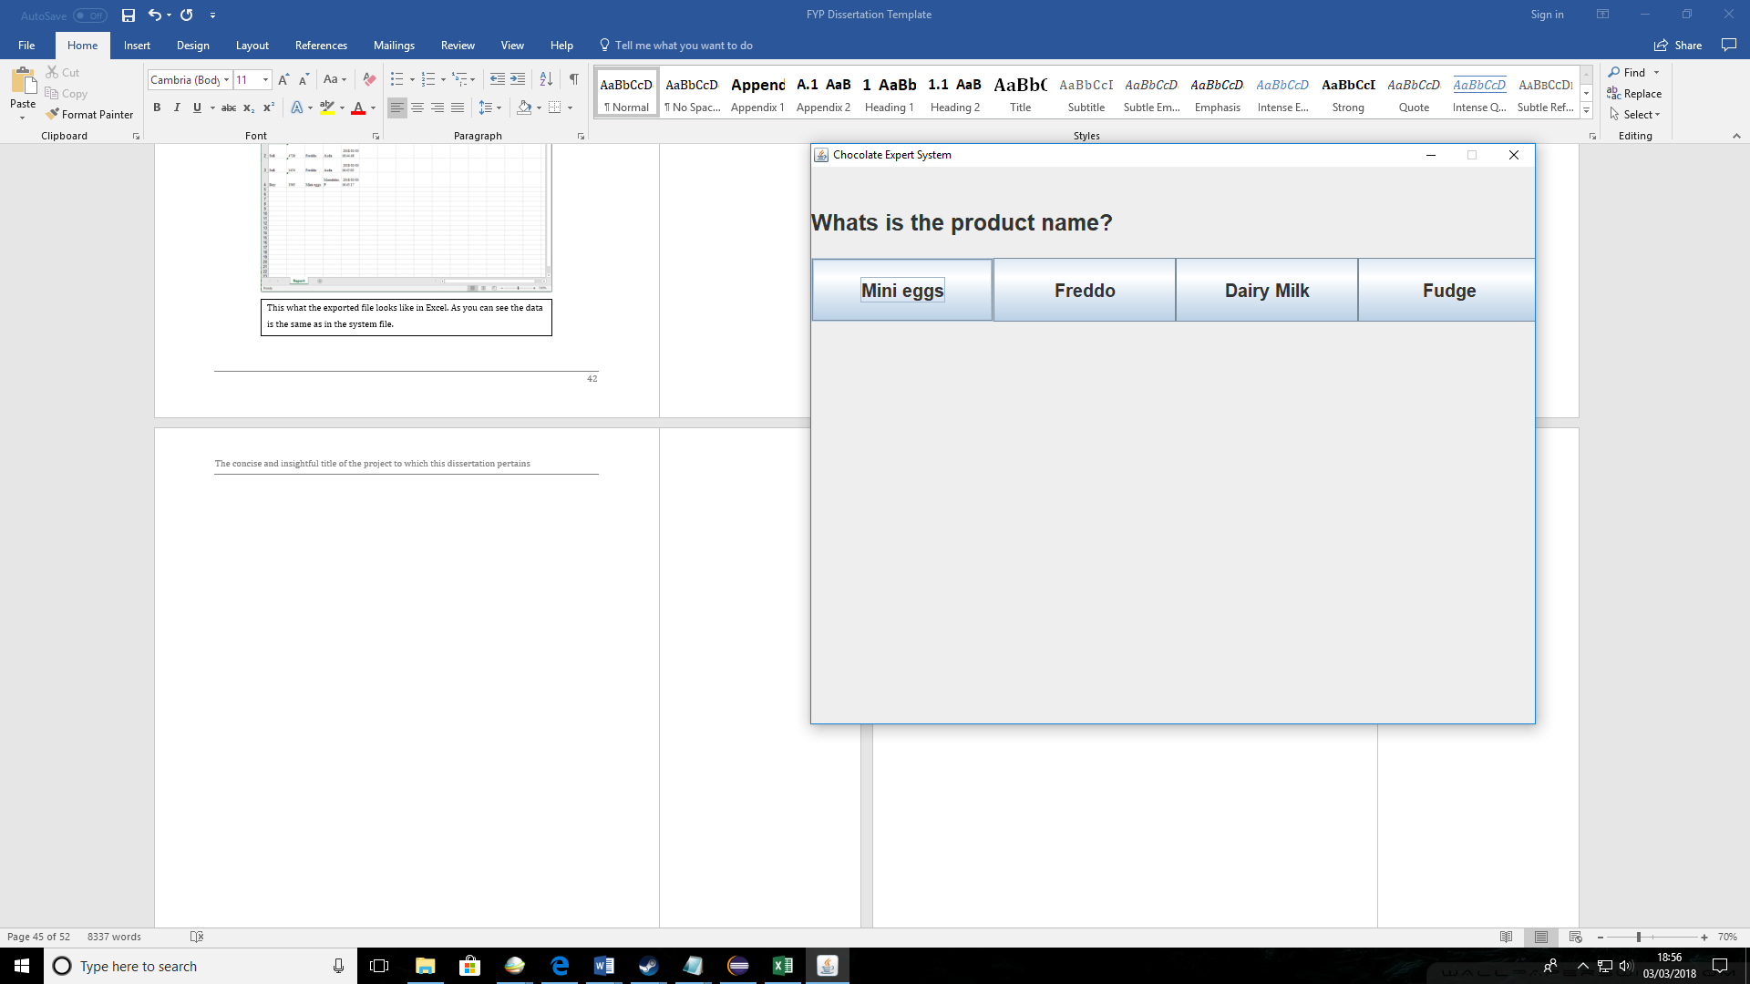

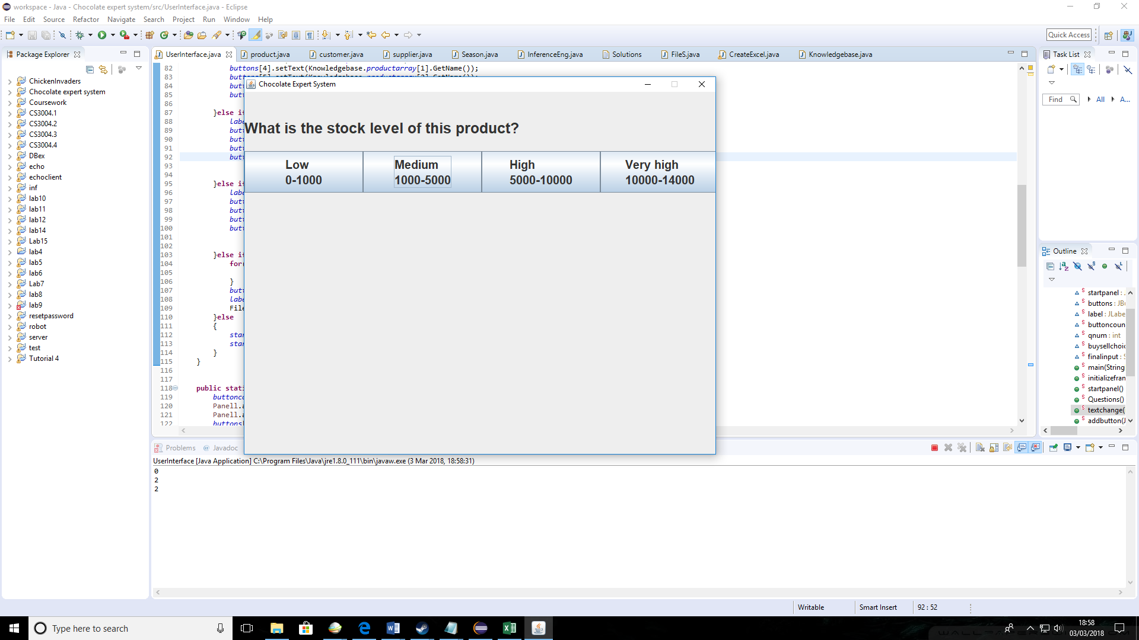

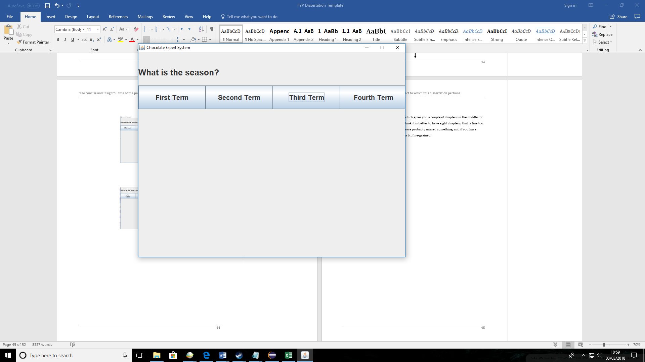

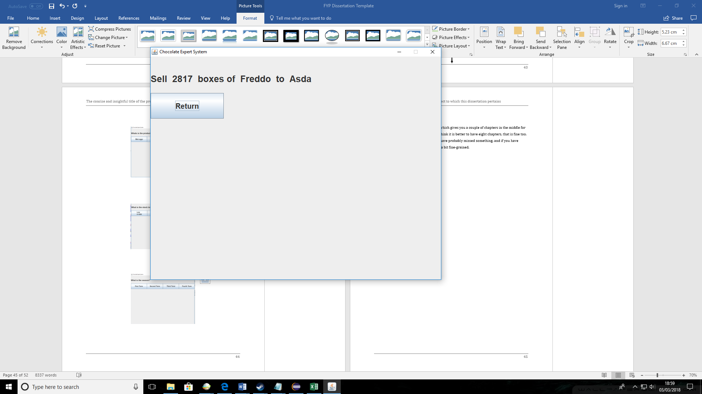

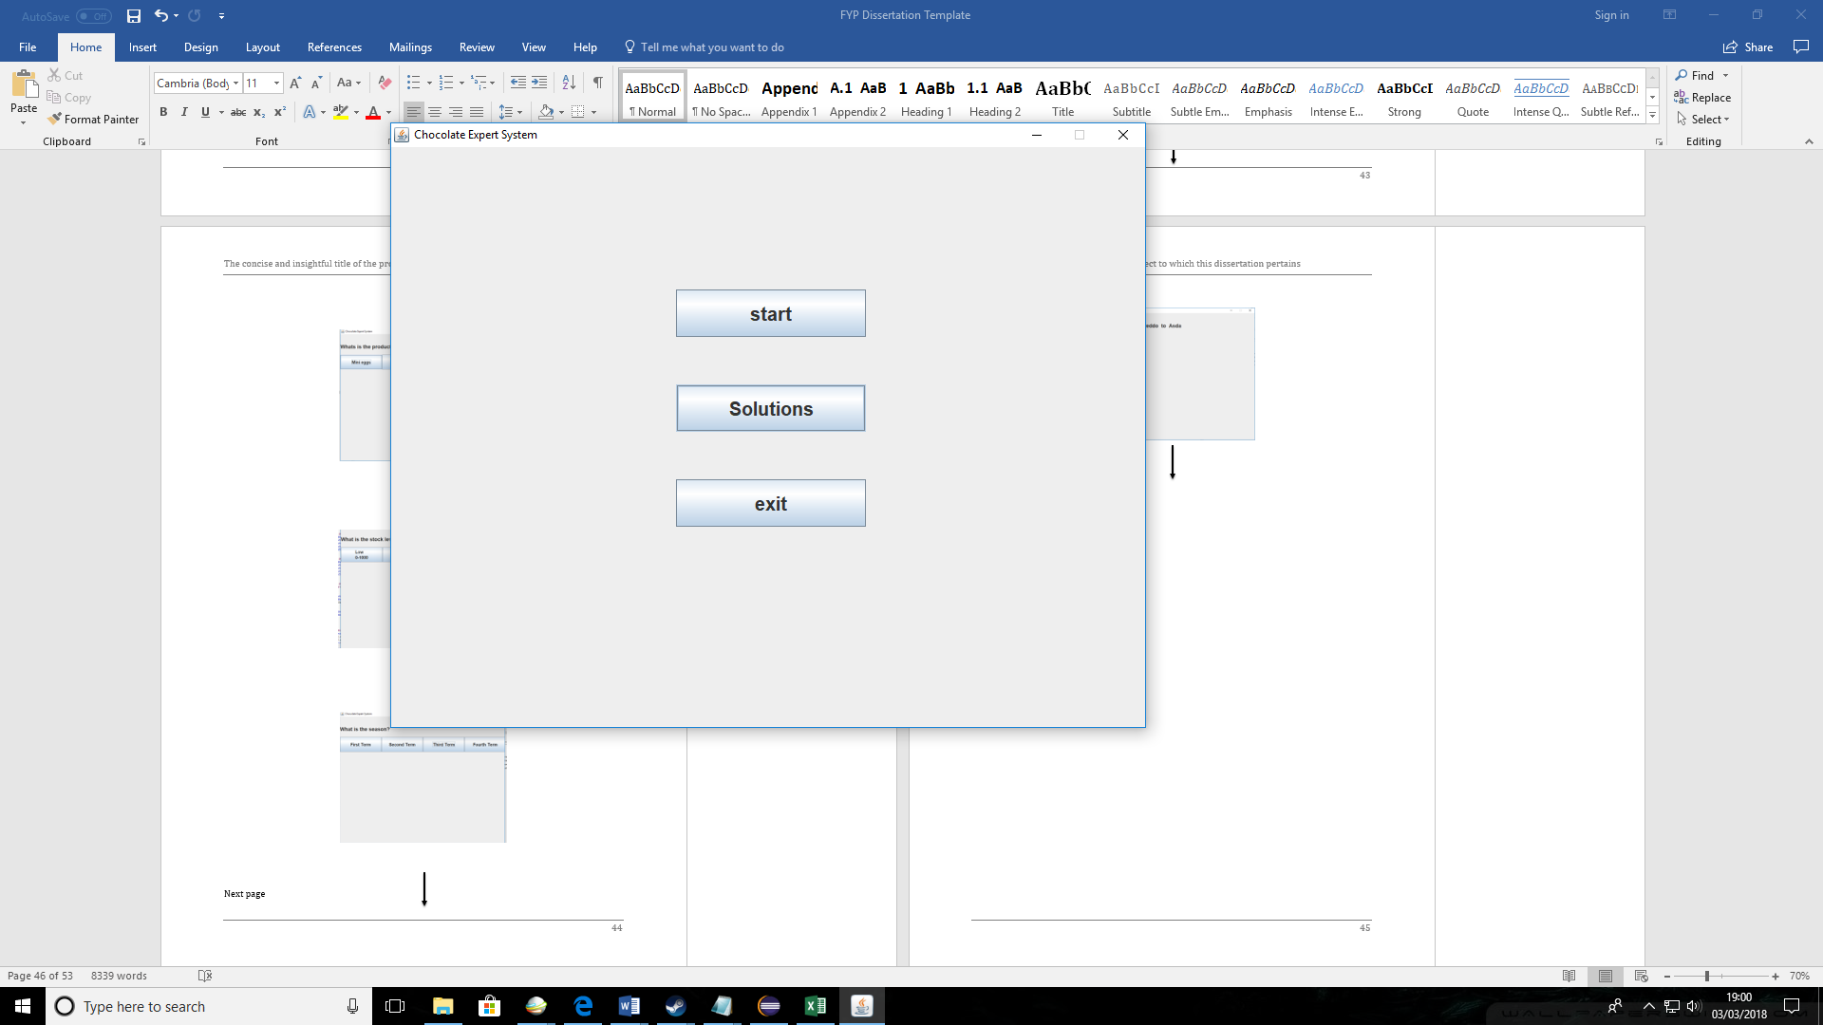

|  |  |  |  |  |  |  |  |  |  |  |  |  |
| --- | --- | --- | --- | --- | --- | --- | --- | --- | --- | --- | --- | --- |
| |  |  |  |  |  |  | | --- | --- | --- | --- | --- | --- | | Ref no | Navigation tested | What test | Test data | Expected outcome | Actual outcome | | N2 | Solution exit button | Once solution is on screen a exit button will also be there. I will press the exit button to see where is takes me | Solution exit button | The solution exit button should take me back to the menu | The button took me to main menu as expected | |
|  |

Input – return button

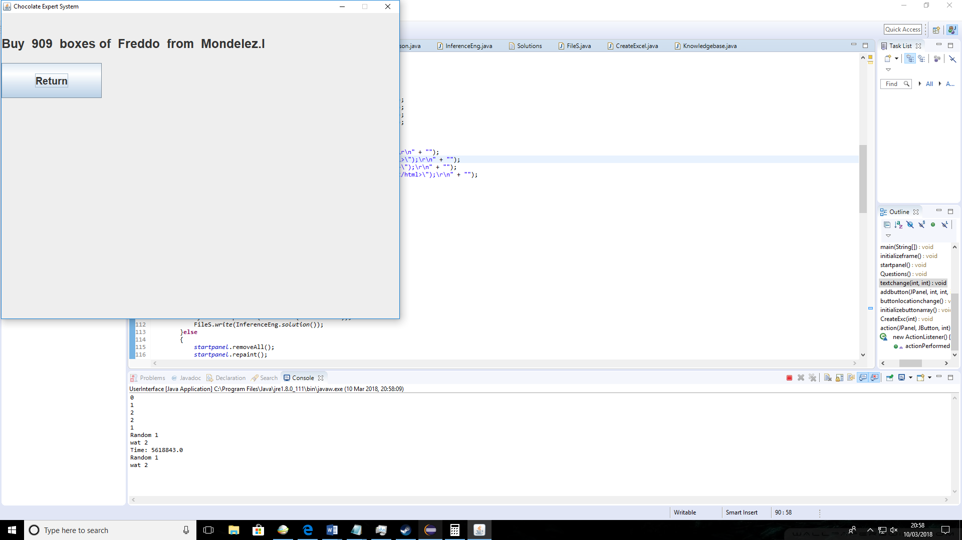

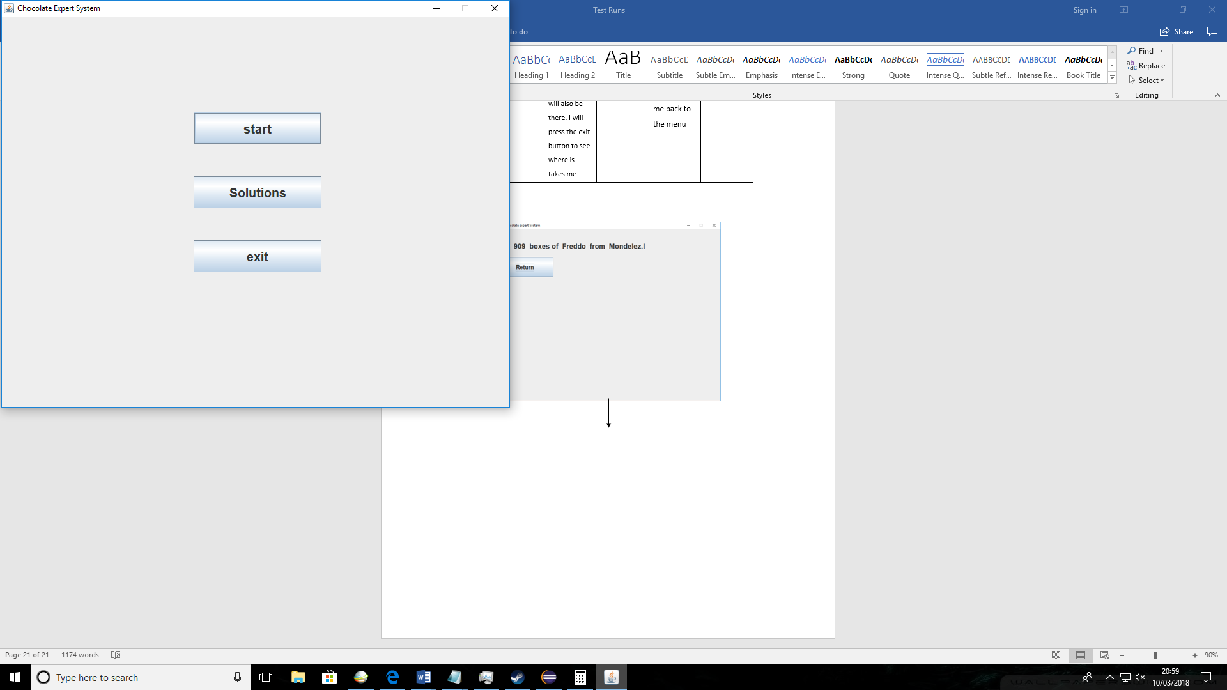

|  |  |  |  |  |  |  |  |  |  |  |  |  |
| --- | --- | --- | --- | --- | --- | --- | --- | --- | --- | --- | --- | --- |
| |  |  |  |  |  |  | | --- | --- | --- | --- | --- | --- | | Ref no | Navigation tested | What test | Test data | Expected outcome | Actual outcome | | N3 | Viewing solutions button | I will press the “Solutions ” button in the menu | Solutions button | The solutions should be displayed | After pressing the “Solutions” button the solutions were displayed as expected | |
|  |

Input – solutions button

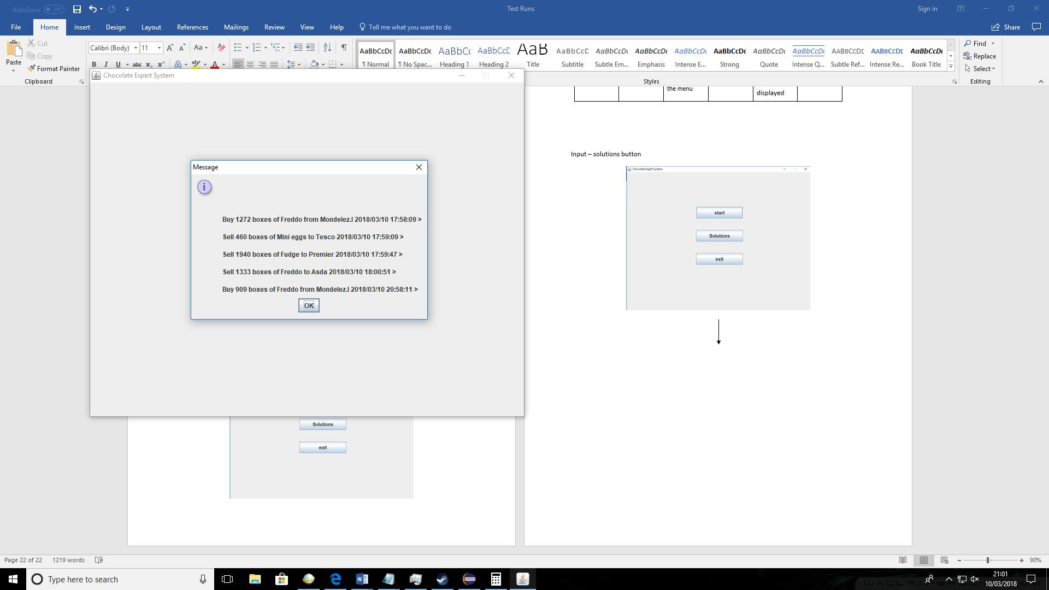

|  |  |  |  |  |  |  |  |  |  |  |  |  |
| --- | --- | --- | --- | --- | --- | --- | --- | --- | --- | --- | --- | --- |
| |  |  |  |  |  |  | | --- | --- | --- | --- | --- | --- | | Ref no | Navigation tested | What test | Test data | Expected outcome | Actual outcome | | N4 | Export Excel file “yes” and “No” buttons | I will test the “yes” button and “no” button to see if they perform correct function | Test 1- “Yes” button  Test 2- “No” button | If “yes” button is pressed new window should diplay asking the user to input save path  If “no” button is pressed the system should return to the main menu | When “Yes ” button was pressed a input dialog was displayed asking to input save path.  When “no” button was pressed system return to main menu. | |
| Input – “yes” button |

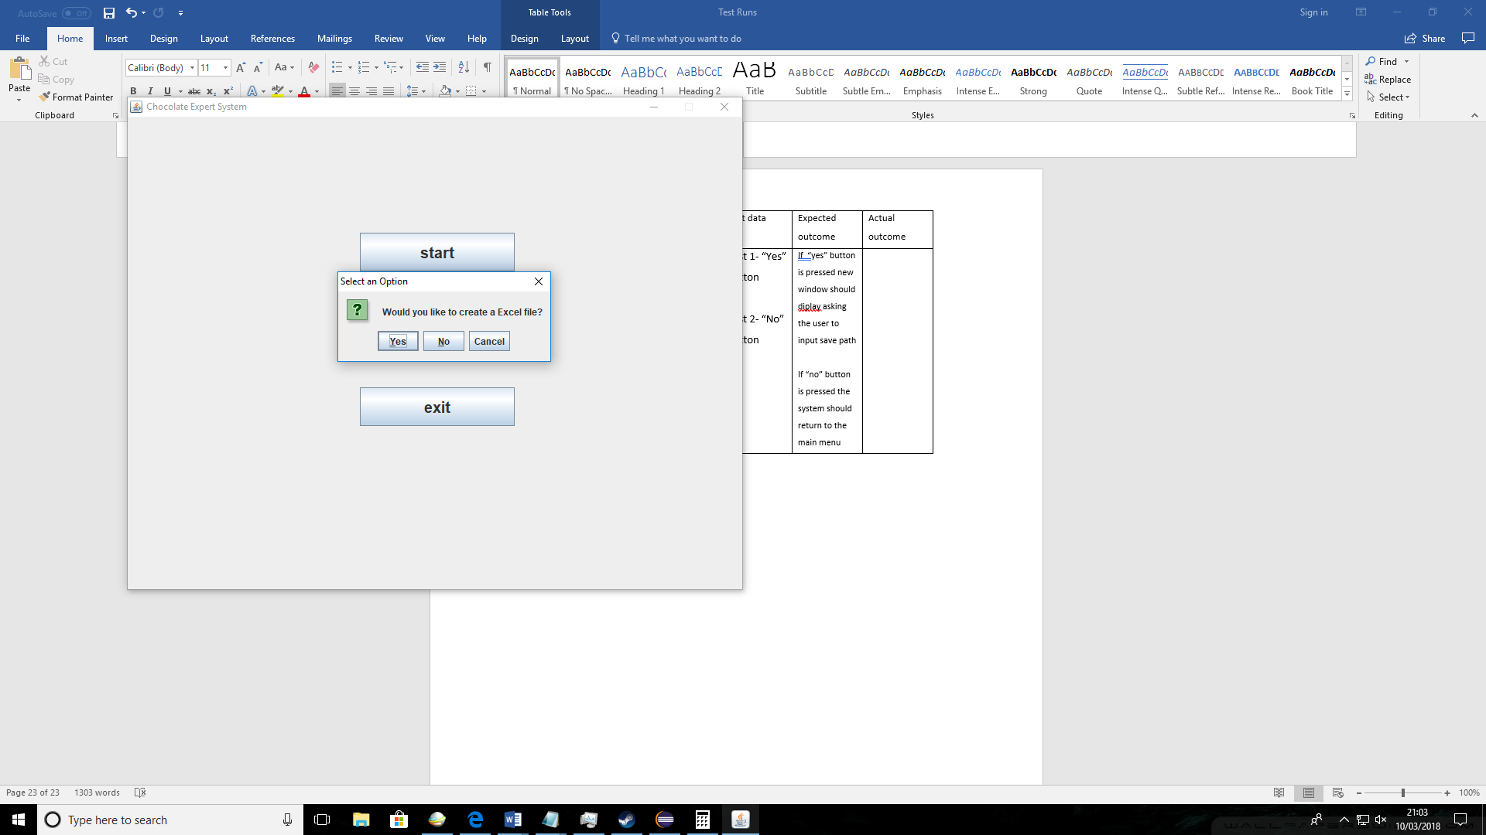

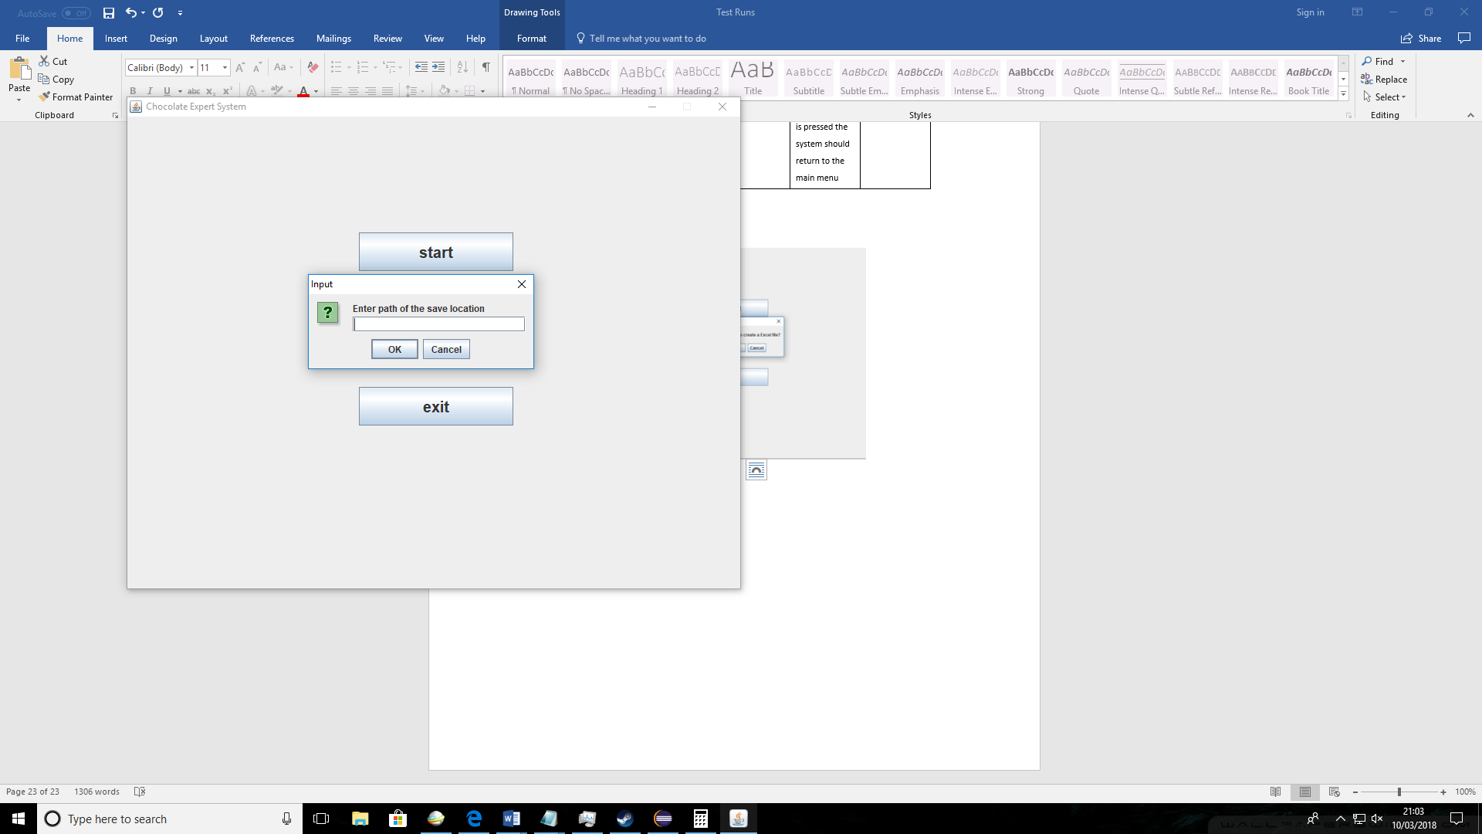

Input – “No” button



|  |  |  |  |  |  |  |  |  |  |  |  |  |
| --- | --- | --- | --- | --- | --- | --- | --- | --- | --- | --- | --- | --- |
| |  |  |  |  |  |  | | --- | --- | --- | --- | --- | --- | | Ref no | Navigation tested | What test | Test data | Expected outcome | Actual outcome | | N5 | Main menu exit button | I will use the exit button in the main menu | Exit button | The program should shut down | The program executed when “Exit” button was pressed | |

Input - exit button

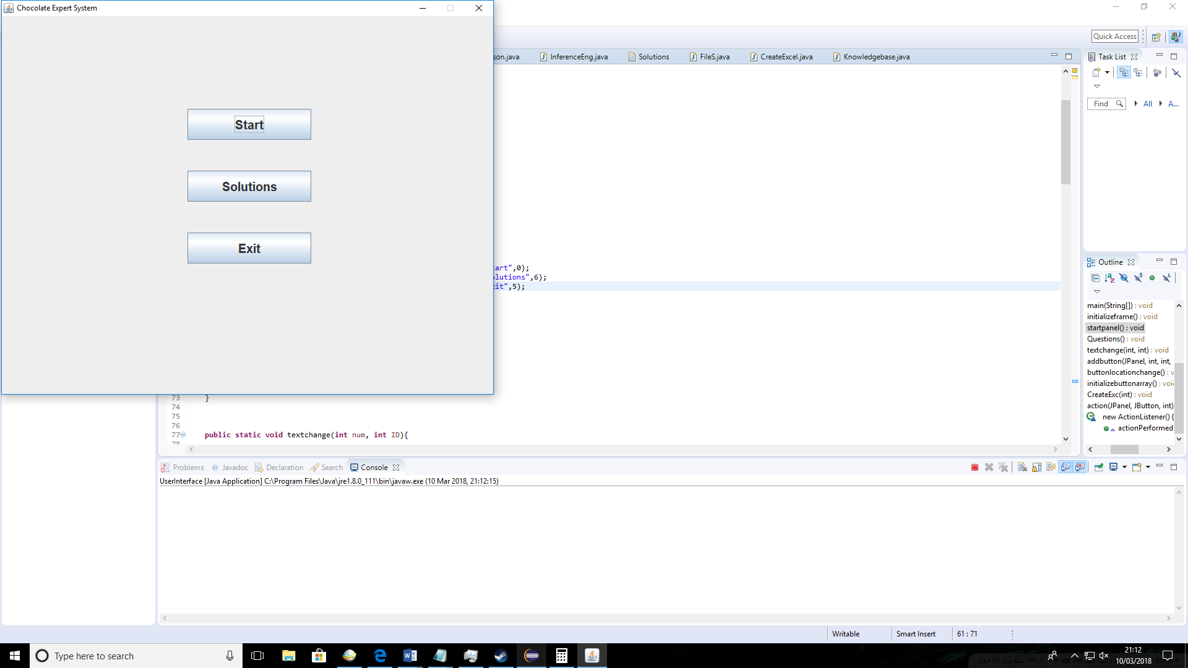

|  |  |  |  |  |  |
| --- | --- | --- | --- | --- | --- |
| Ref no | Solution tested | What test | Test data | Expected outcome | Actual outcome |
| A1 | Buying products solution | Buying mini eggs from a supplier | Product: Mini eggs  Quantity: Low  Season: Season 1 | The appropriate supplier should be found. In this case Random one since product “Mini eggs” doesn’t have most popular supplier. | The supplier was picked at random as expected. The quantity stayed for both results stayed the same as expected. |

Input combination- Buy/Mini eggs/Low/ Season 1

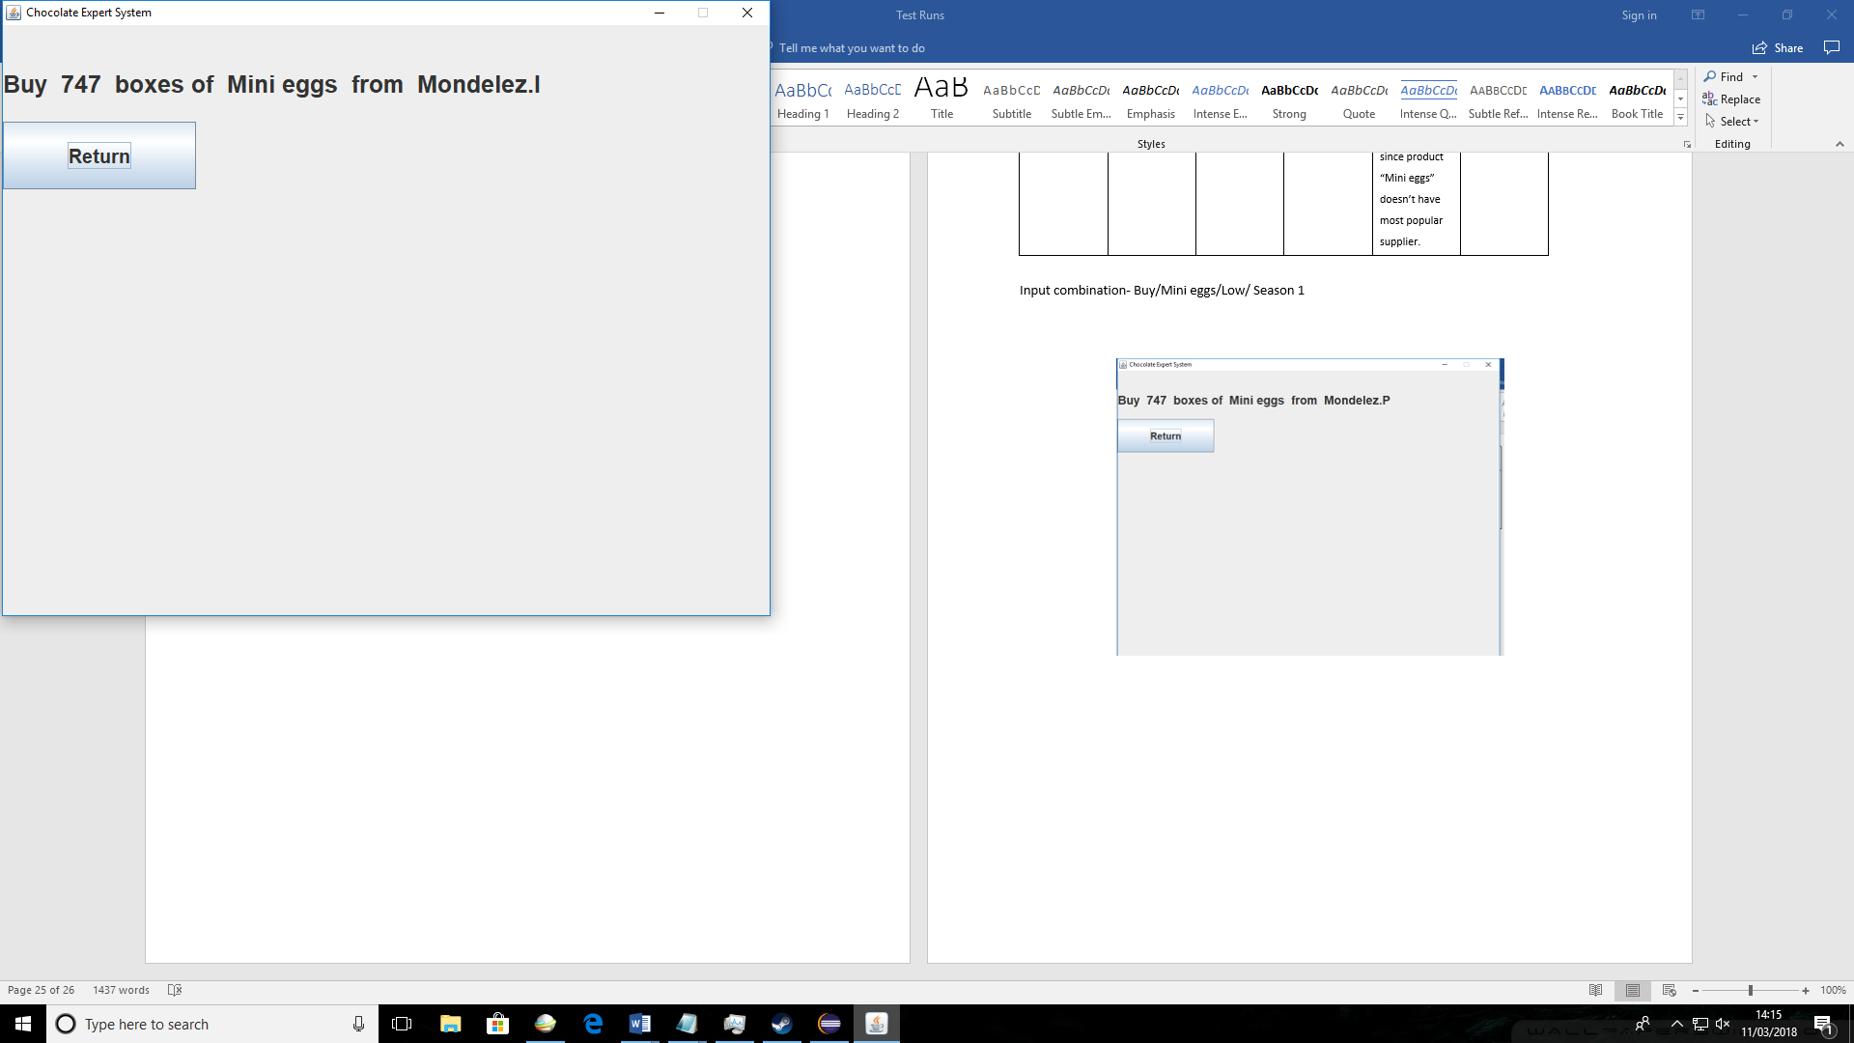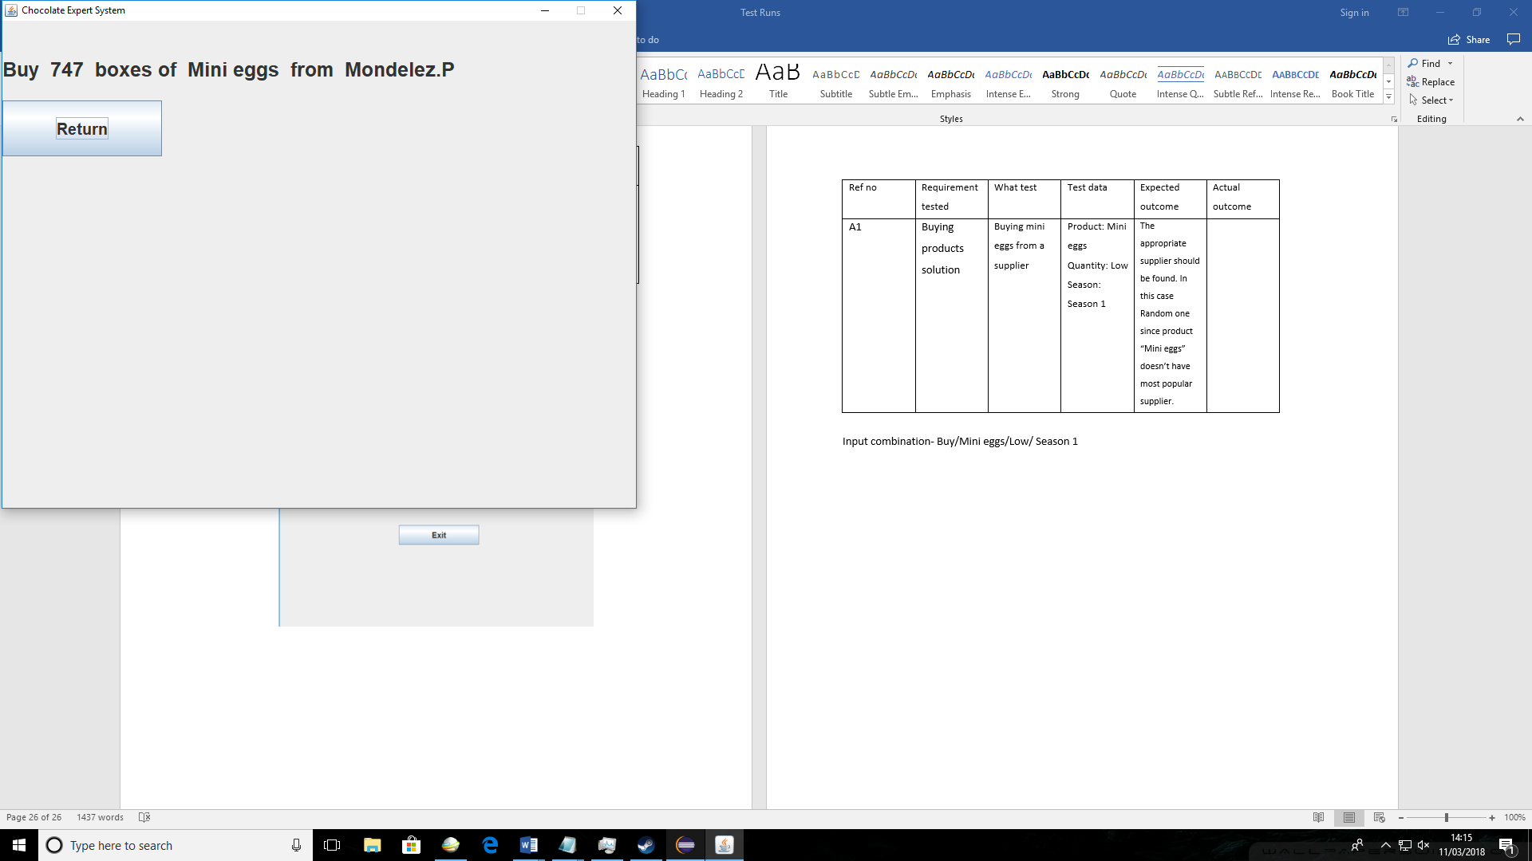

|  |  |  |  |  |  |
| --- | --- | --- | --- | --- | --- |
| Ref no | Solution tested | What test | Test data | Expected outcome | Actual outcome |
| A2 | Buying products solution | Buying mini eggs from a supplier | Product: Mini eggs  Quantity: Very High  Season: Season 1 | Random supply should be found same as in A1 test since it’s same product. The quantity in solution should be reduced sine current quantity for this product is already very high therefore no need to buy more. | The supplier found was random as expected. The quantity is lower than in A1 test since the quantity was changed from low to very high therefore less products need to be ordered. |

Input combination- Buy/Mini eggs/Very high/ Season 1

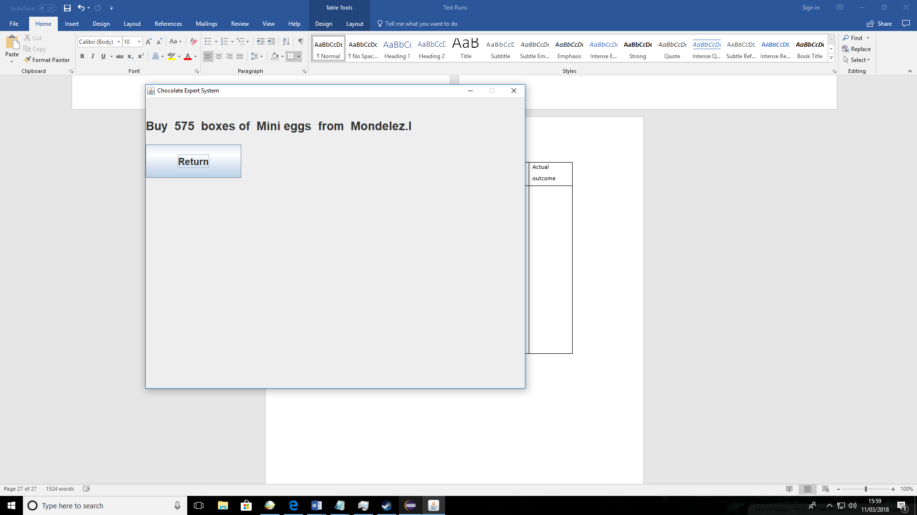

|  |  |  |  |  |  |
| --- | --- | --- | --- | --- | --- |
| Ref no | Solution tested | What test | Test data | Expected outcome | Actual outcome |
| A3 | Buying products solution | Buying mini eggs from a supplier | Product: Mini eggs  Quantity: Low  Season: Season 4 | Random supply should be picked since product is the same as in A1 test. The quantity generated should be higher than in A1 since the season I shoes “Season 4” is more popular than “Season 1” in A1 test. | The supplier found was random as expected. The products quantity increased from A1 since season 4 is more popular than season 1 picked in A1 test. |

Input combination- Buy/Mini eggs/Low/ Season 4

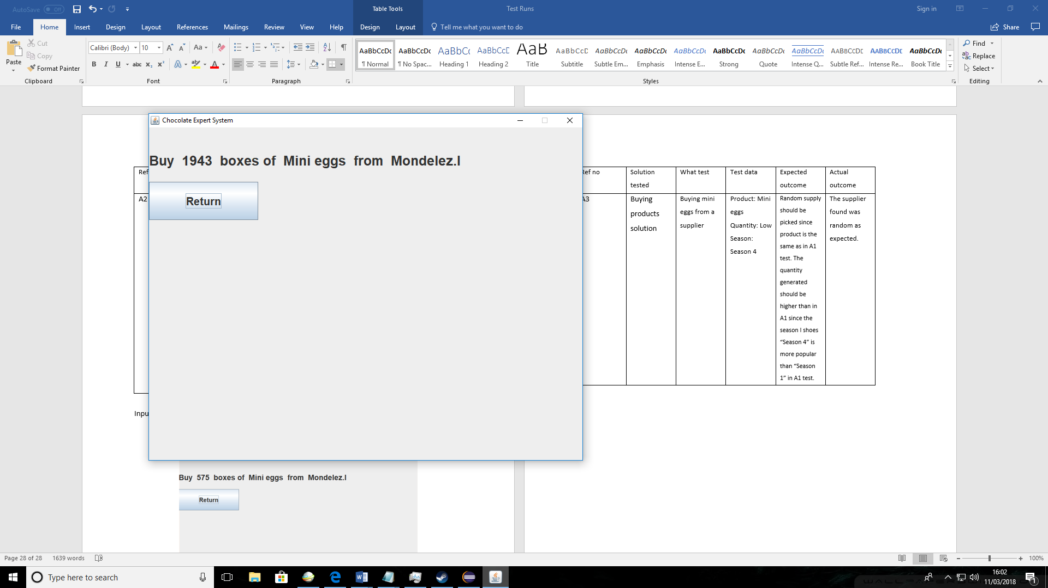

|  |  |  |  |  |  |
| --- | --- | --- | --- | --- | --- |
| Ref no | Solution tested | What test | Test data | Expected outcome | Actual outcome |
| A4 | Buying products solution | Buying Fudge from a supplier | Product: Fudge  Quantity: Low  Season: Season 1 | The correct supplier should be found for the product “Fudge” in this case it should be “Mondelez.E” | The correct supplier “Mondele.E” was picked as expected. |

Input combination- Buy/Fudge/Low/ Season 1

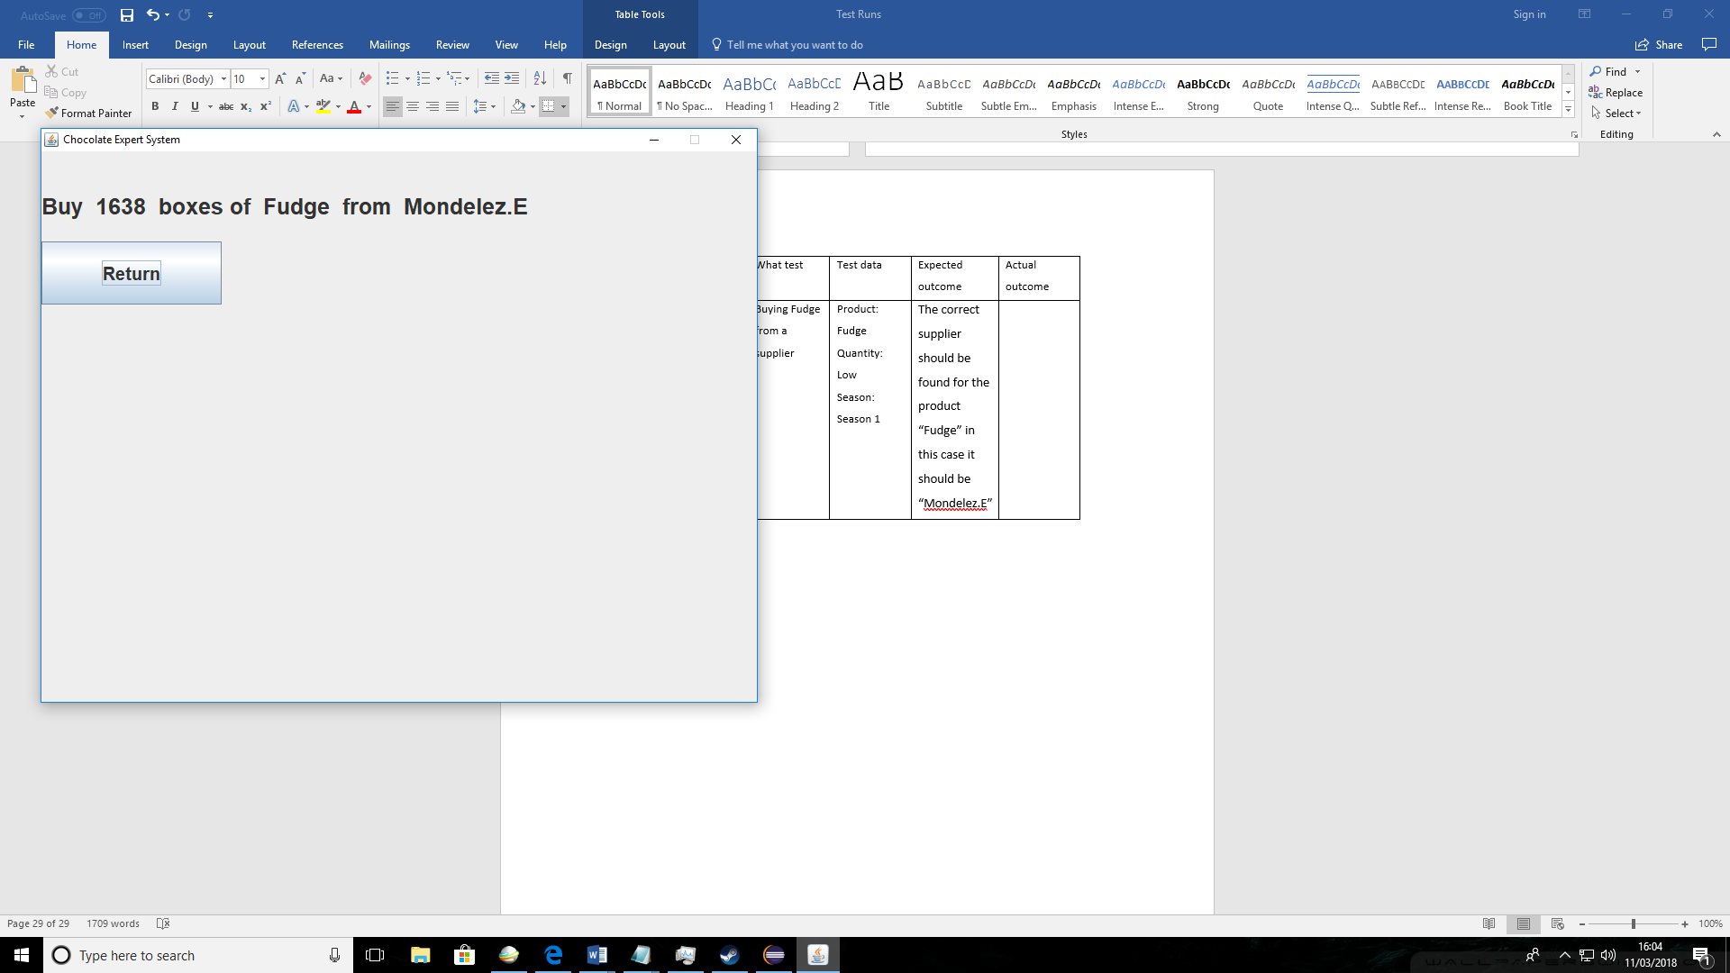

|  |  |  |  |  |  |
| --- | --- | --- | --- | --- | --- |
| Ref no | Solution tested | What test | Test data | Expected outcome | Actual outcome |
| A5 | Buying products solution | Buying Fudge from a supplier | Product: Fudge  Quantity: High  Season: Season 1 | The supplier should be same as in A4 test since it’s same product. The quantity should be smaller since the current quantity of the product is high. | Same supplier was as in A4 because product is the same. The product quantity in solution was reduced. |

Input combination- Buy/Fudge/High/ Season 1

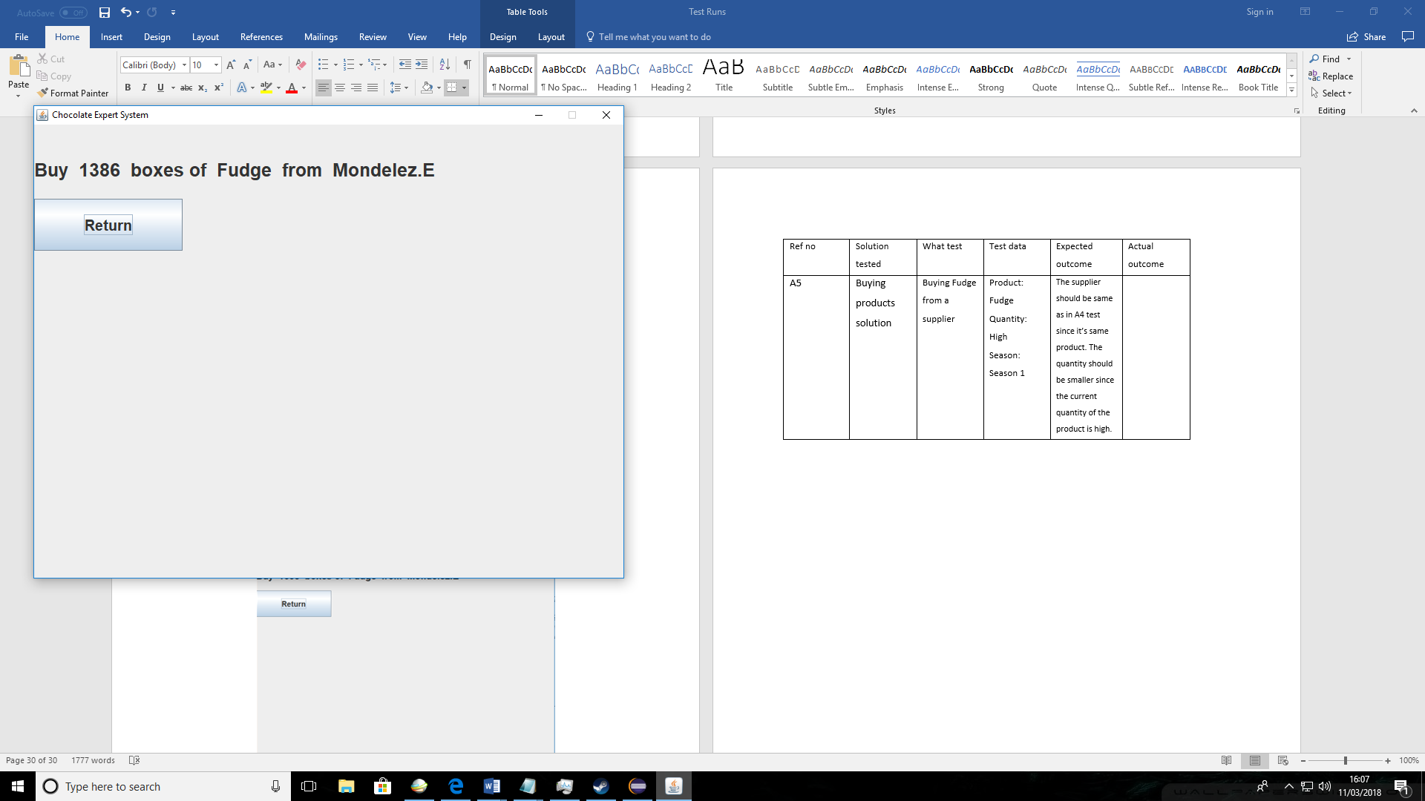

|  |  |  |  |  |  |
| --- | --- | --- | --- | --- | --- |
| Ref no | Solution tested | What test | Test data | Expected outcome | Actual outcome |
| A6 | Buying products solution | Buying Fudge from a supplier | Product: Fudge  Quantity: Low  Season: Season 4 | Supplier should be same as in Test A4. The quantity to buy in solution should increase from A4 since the “Season 4” is more popular than season 1 in test A4 | Same supplier was as in A4 because product is the same. The quantity increased since more popular season was chosen. |

Input combination- Buy/Fudge/Low/ Season 4

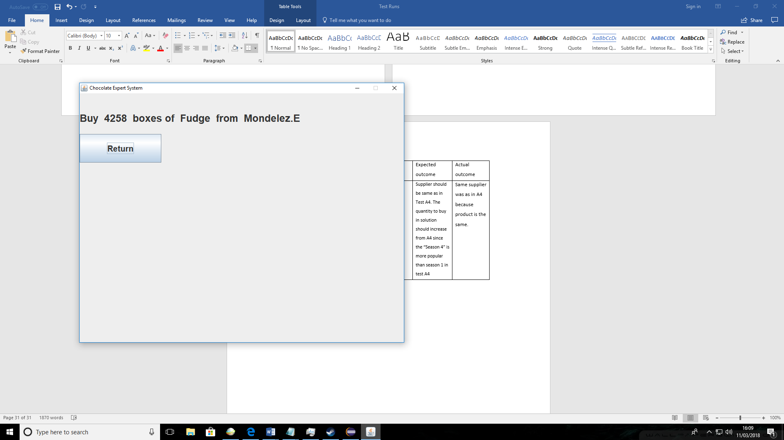

|  |  |  |  |  |  |
| --- | --- | --- | --- | --- | --- |
| Ref no | Solution tested | What test | Test data | Expected outcome | Actual outcome |
| A7 | Selling products solution | Selling Mini eggs to customer | Product: Mini eggs  Quantity: Low  Season: Season 1 | A appropriate customer should be picked by the system. In this case “Tesco” | The correct customer was picked “Tesco” |

Input combination- Sell/Mini eggs/Low/ Season 1

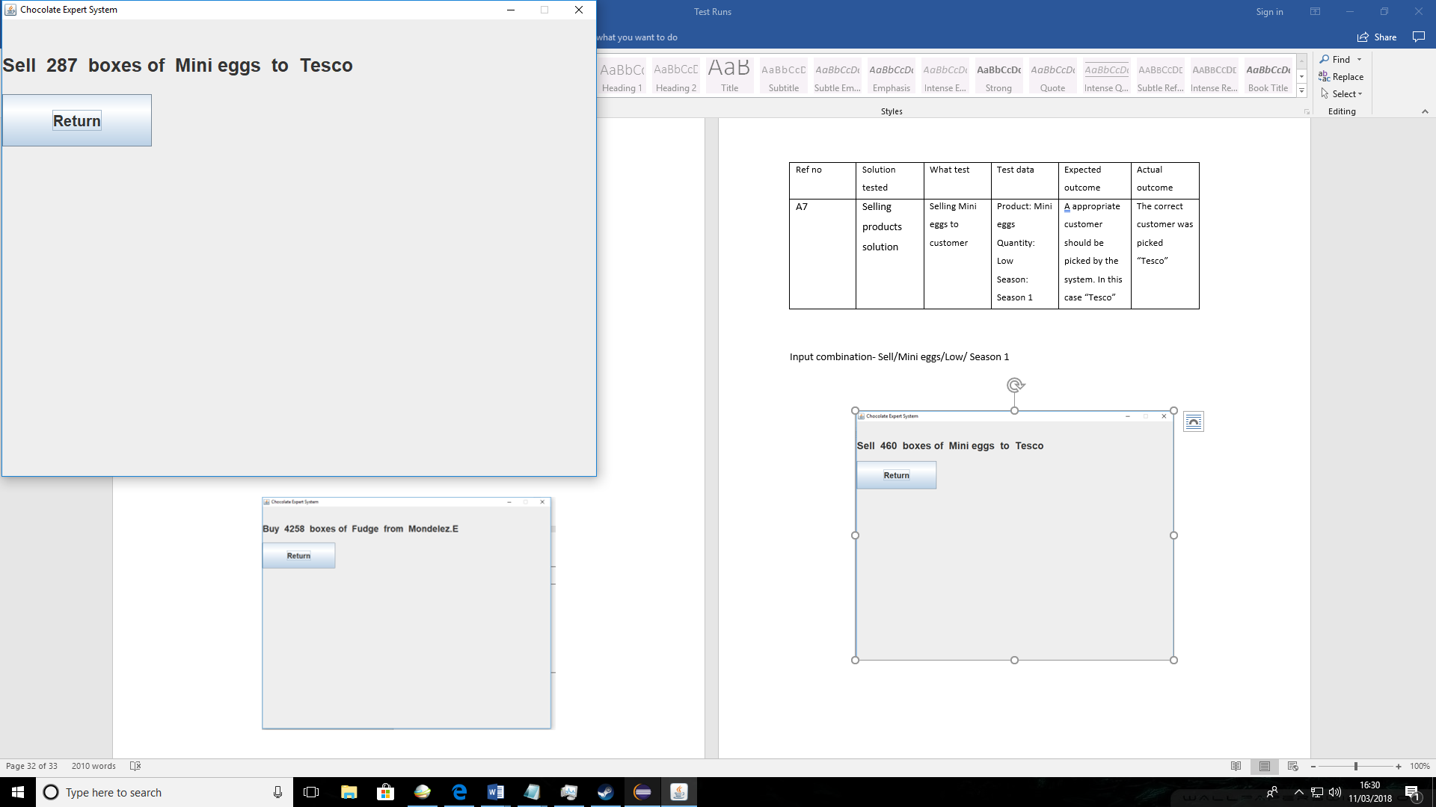

|  |  |  |  |  |  |
| --- | --- | --- | --- | --- | --- |
| Ref no | Solution tested | What test | Test data | Expected outcome | Actual outcome |
| A8 | Selling products solution | Selling Mini eggs to customer | Product: Mini eggs  Quantity: Very high  Season: Season 1 | The same customer should have been chosen as in A7. The quantity should be higher since the current quantity of this product is high therefore more can be sold. | The correct customer was picked “Tesco”. |

Input combination- Sell/Mini eggs/Very high/ Season 1

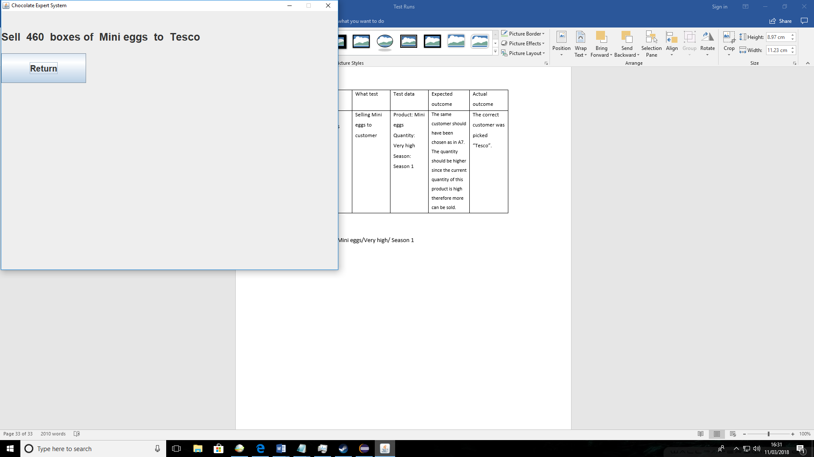

|  |  |  |  |  |  |
| --- | --- | --- | --- | --- | --- |
| Ref no | Solution tested | What test | Test data | Expected outcome | Actual outcome |
| A9 | Selling products solution | Selling Mini eggs to customer | Product: Mini eggs  Quantity: Low  Season: Season 4 | The same customer should have been chosen as in A7. The quantity in solution should also be higher since more popular season has been chosen “Season 4” then in A7. | The correct customer was picked “Tesco”. The solution quantity was higher since more popular season was picked. |

Input combination- Sell/Mini eggs/Low/ Season 4

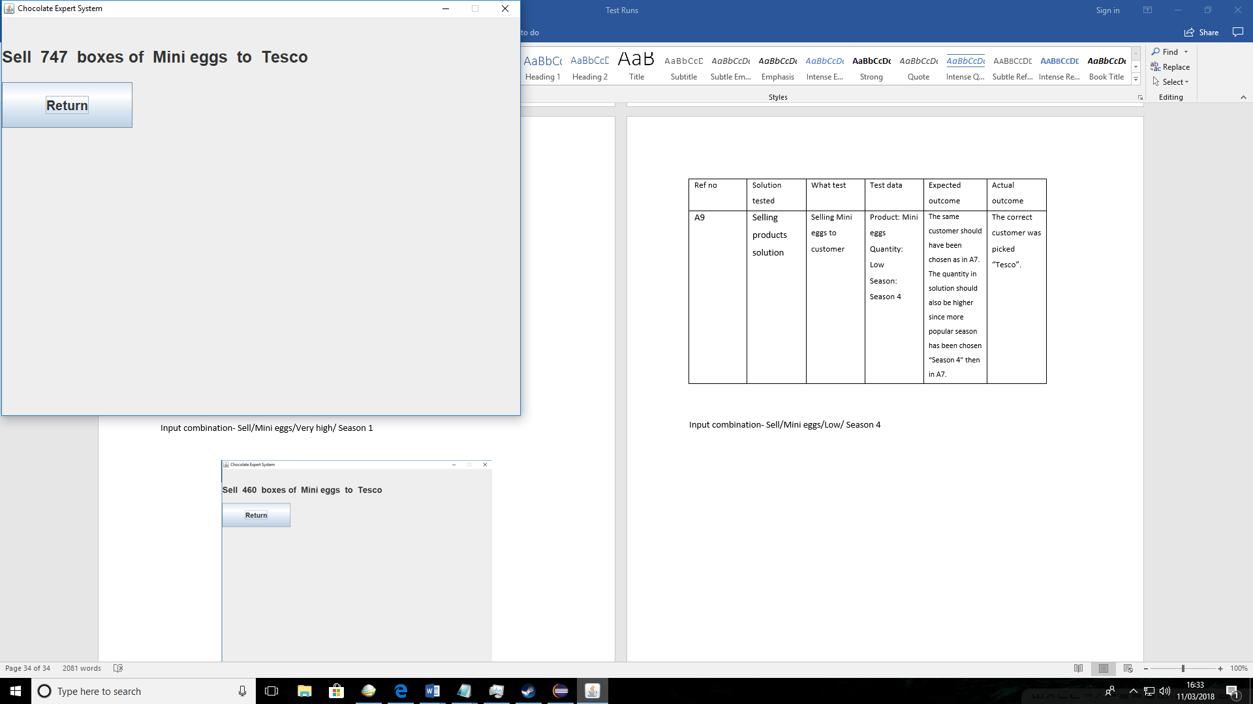

|  |  |  |  |  |  |
| --- | --- | --- | --- | --- | --- |
| Ref no | Solution tested | What test | Test data | Expected outcome | Actual outcome |
| A10 | Selling products solution | Selling Fudge to customer | Product: Fudge  Quantity: Low  Season: Season 1 | The customer will be chosen randomly by the system because there Is no preferable customer for this product. | The customer chosen changes as shown in 2 screenshots. |

Input combination- Sell/Fudge/Low/ Season 1

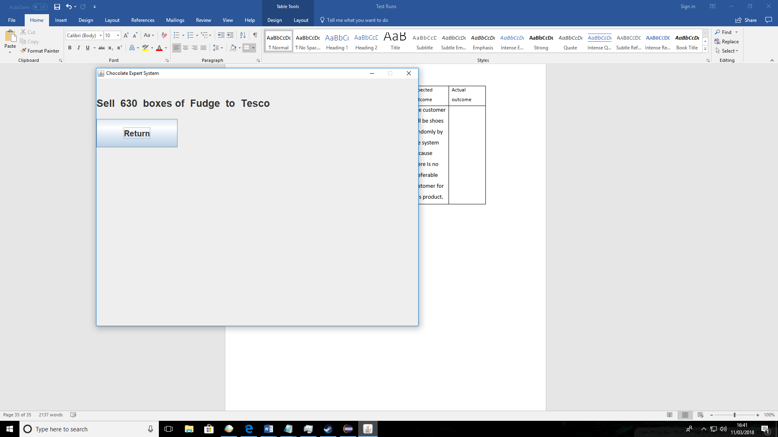

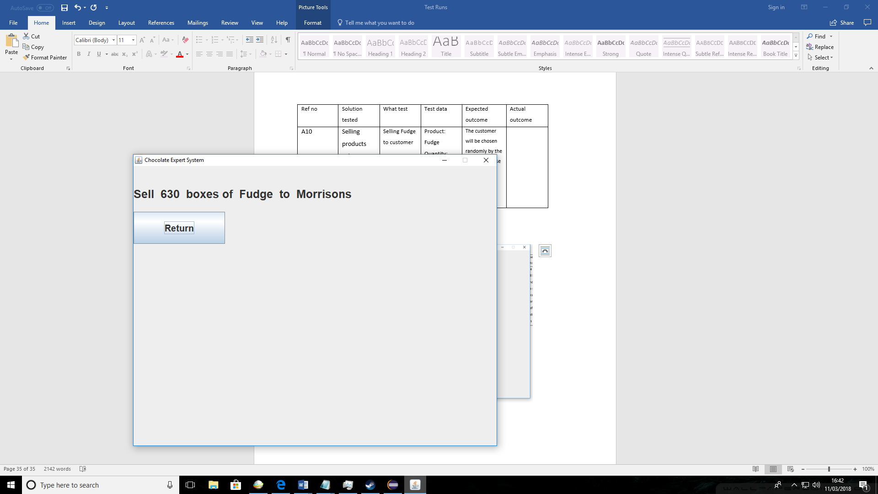

|  |  |  |  |  |  |
| --- | --- | --- | --- | --- | --- |
| Ref no | Solution tested | What test | Test data | Expected outcome | Actual outcome |
| A11 | Selling products solution | Selling Fudge to customer | Product: Fudge  Quantity: Very high  Season: Season 1 | The customer will be choosing randomly same as in A10 since it’s same product. The quantity in solution should be higher than in A10 since current quantity of that product is very high. | The quantity of the solution was higher than in A10 because current quantity of “Fudge” is Very high therefore more should be sold |

Input combination- Sell/Fudge/Very high/ Season 1

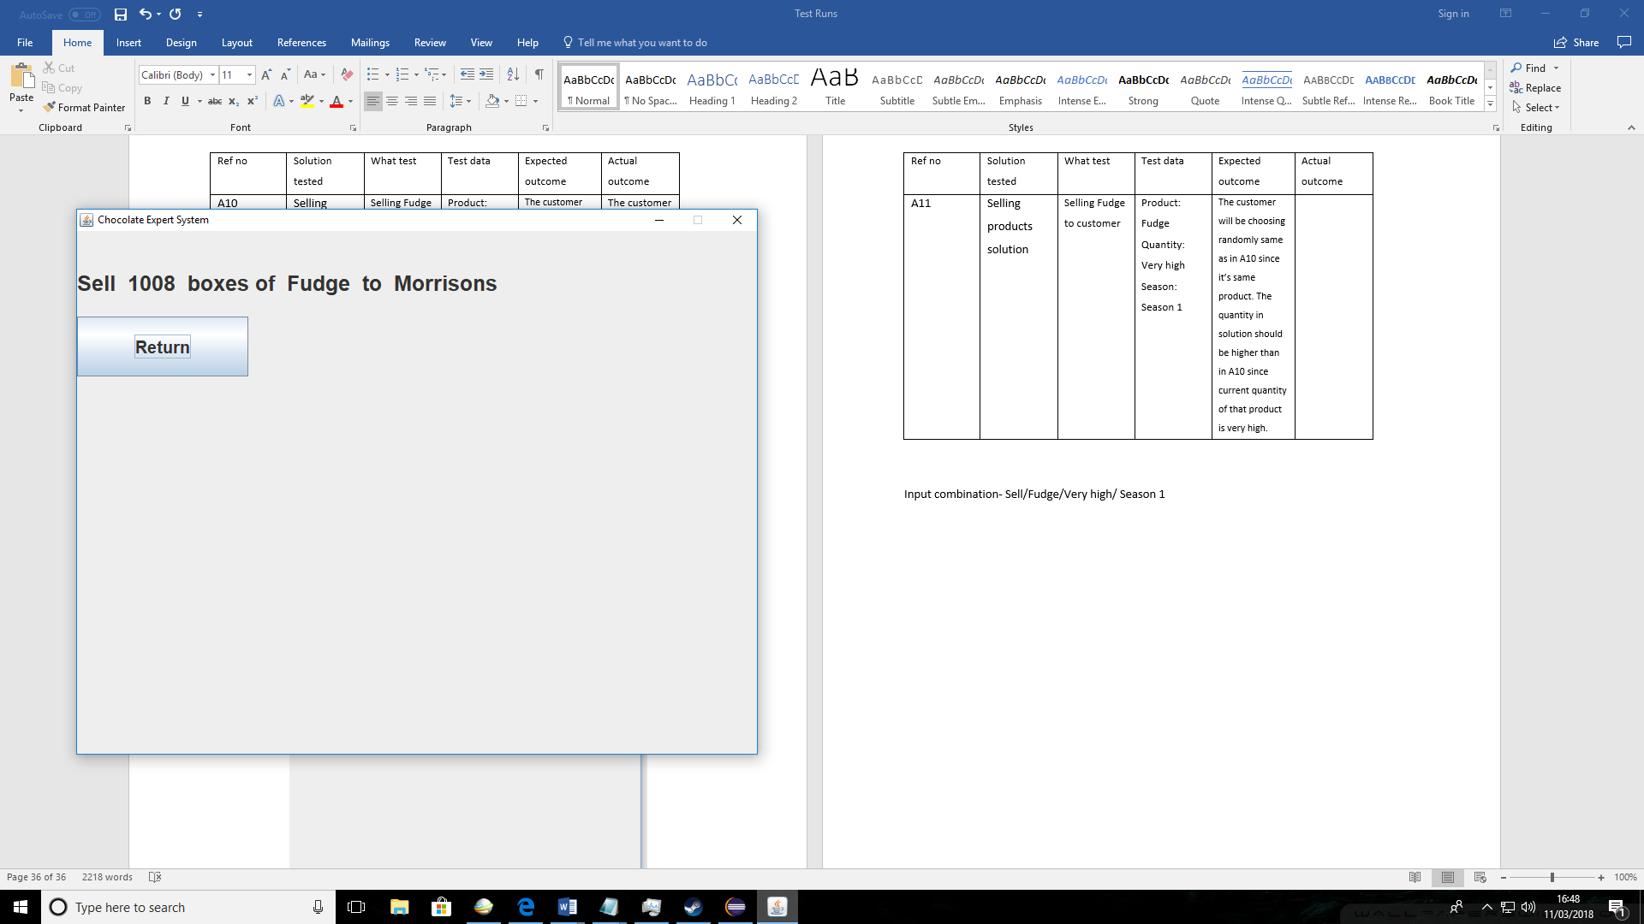

|  |  |  |  |  |  |
| --- | --- | --- | --- | --- | --- |
| Ref no | Solution tested | What test | Test data | Expected outcome | Actual outcome |
| A12 | Selling products solution | Selling Fudge to customer | Product: Fudge  Quantity: Low  Season: Season 4 | The customer will be choosing randomly same as in A10 since it’s same product. The quantity in solution should be increased from A10 because more popular season has been chosen. | The solution quantity was higher than in A10 because more popular Season was picked. |

Input combination- Sell/Fudge/Low/ Season 4

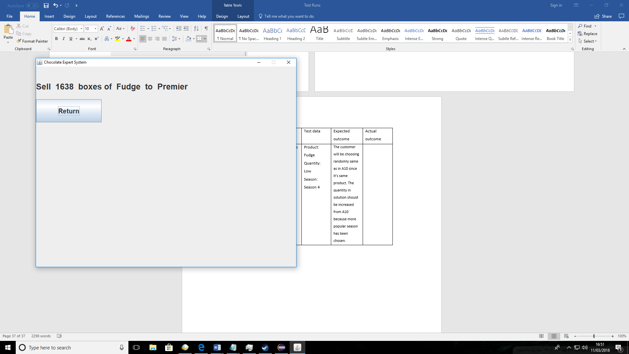

User testing

|  |  |  |  |  |  |
| --- | --- | --- | --- | --- | --- |
| Ref no | Solution tested | What test | Test data | Expected outcome | Actual outcome |
| C1 | Buying products solution | I will ask the user to buy some products from supplier | Answer to first question- Buying | The user should be able to start the system and get a solution for buying stock | The user had no problem with generating the solution and gave me feedback on the solution. |

I asked my client to use the system generate a solution for buying stock from a supplier.

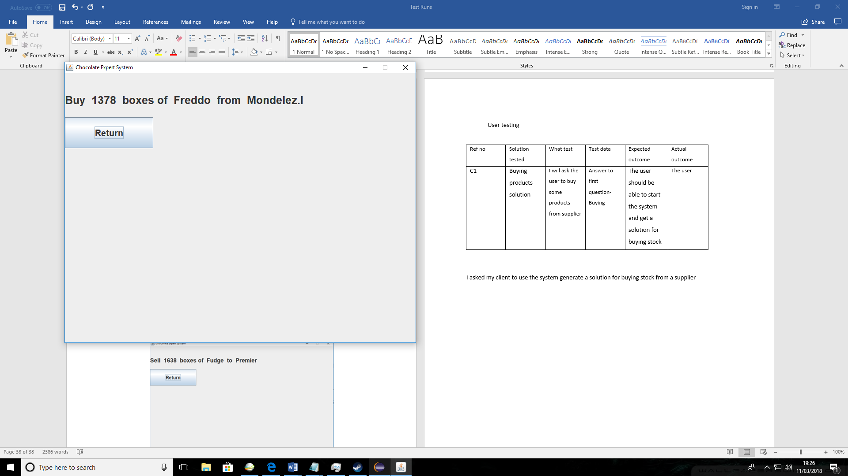

Feedback from user: The user told me that the accuracy of the solution was good and there was no issue with it. The quantity and supplier picked was same as what the expert(client) would have chosen.

|  |  |  |  |  |  |
| --- | --- | --- | --- | --- | --- |
| Ref no | Solution tested | What test | Test data | Expected outcome | Actual outcome |
| C2 | Selling products solution | will ask the user to sell stock to customer | Answer to first question -Selling | The user should be able to start the system and get a solution for selling stock | .The user successfully generated solution for selling stock |

I asked my client to use the system generate a soluti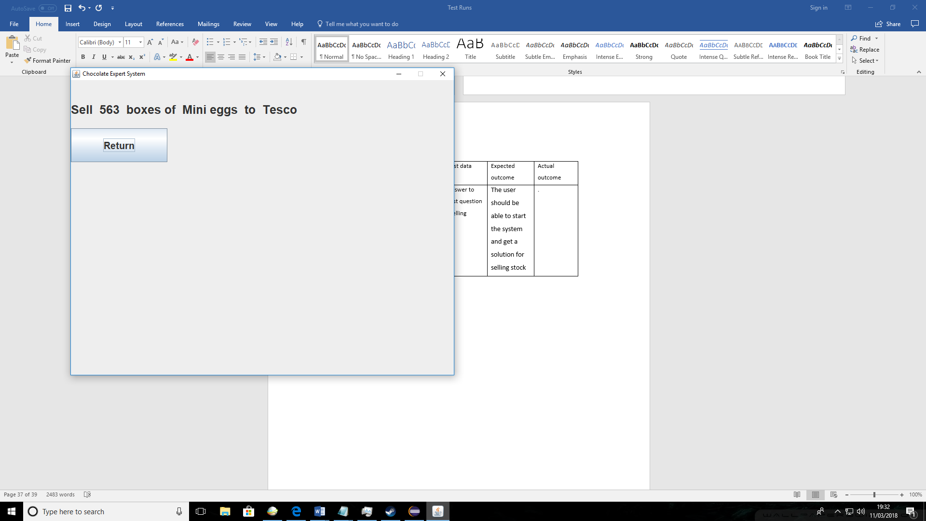on for selling stock to a customer.

Feedback from user: The user told me that the accuracy of the solution was good and there was no issue with it. The amount of boxes sold was just right since it didn’t exceed the amount currently in stock which was high(5000-10000) in this case.

|  |  |  |  |  |  |
| --- | --- | --- | --- | --- | --- |
| Ref no | Solution tested | What test | Test data | Expected outcome | Actual outcome |
| C3 | Viewing solutions | User will be asked to view the previous solutions | Solutions button | User should find solution button and press it too view solutions in file | The user had no problem with viewing the solution and gave me ideas for improvement in feedback |

I have asked my client to use the “Solutions” button and view previous solutions

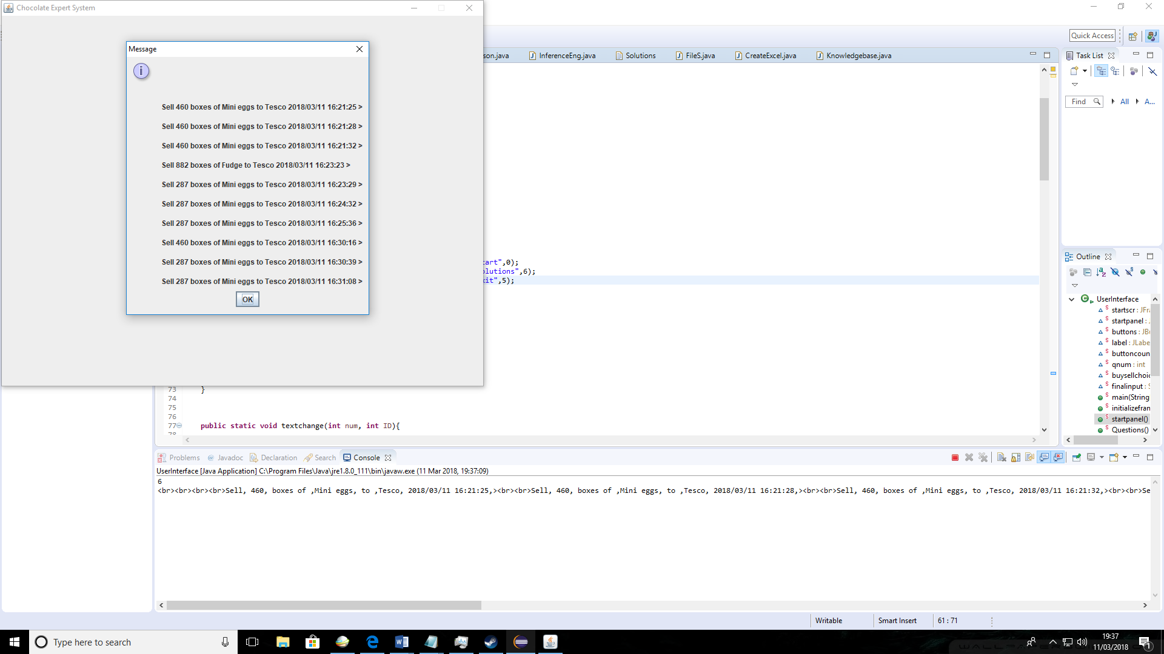

Feedback from user: My user was happy with this function since it was one my client’s requirements. She also gave a suggestion for an improvement which was to let the user amend the data in the file from the system.

Apart from that client was happy with the results

|  |  |  |  |  |  |
| --- | --- | --- | --- | --- | --- |
| Ref no | Solution tested | What test | Test data | Expected outcome | Actual outcome |
| C4 | Exporting solutions to Excel file | I will ask the user after viewing the solutions to expert them to an Excel file | Export button | The system should ask the user if s/he wants to export to Excel and then user should press yes. | .The user successfully exported Excel file. The user also gave ideas for improvement |

I have asked my user to export the results from file to an Excel file.

Feedback: The user was happy with the system and the Export file to excel feature. The client also said the path input can be improved in the future by allowign the user to chose a file in the file explorer instead of typing in the whole path.

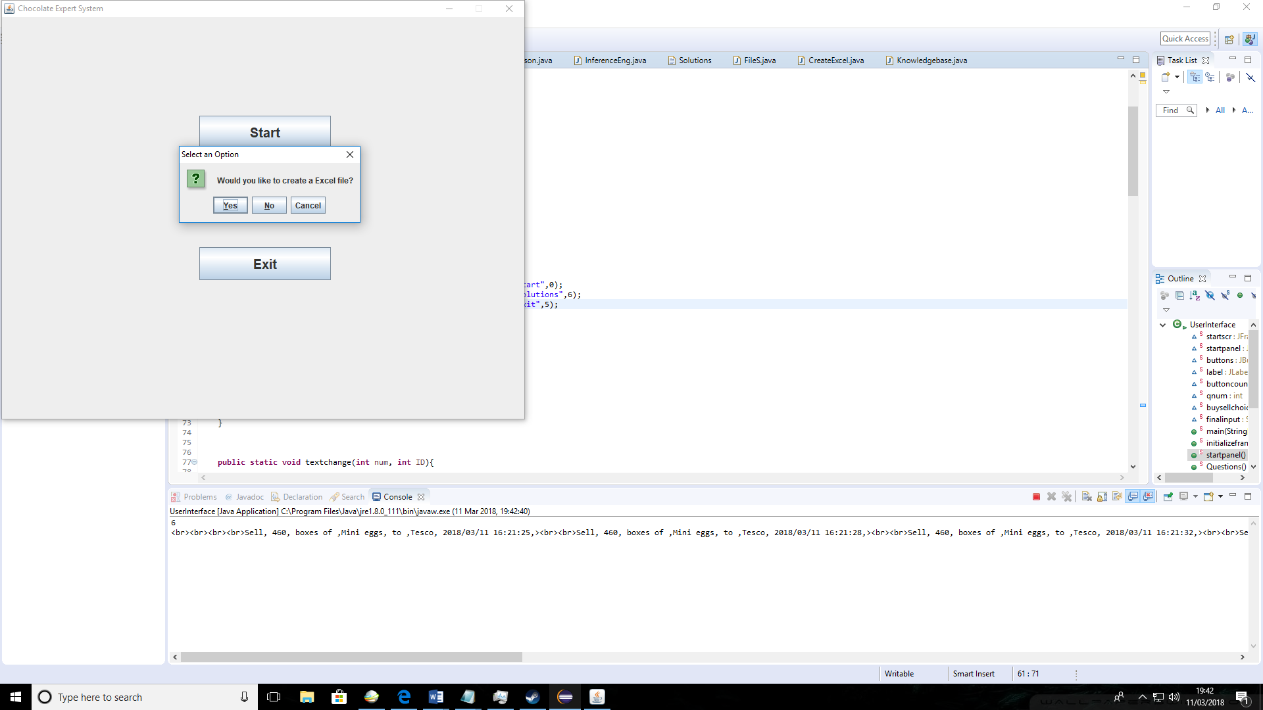

I told my client to just use the path I normally use for saving since my computer was used for the testing

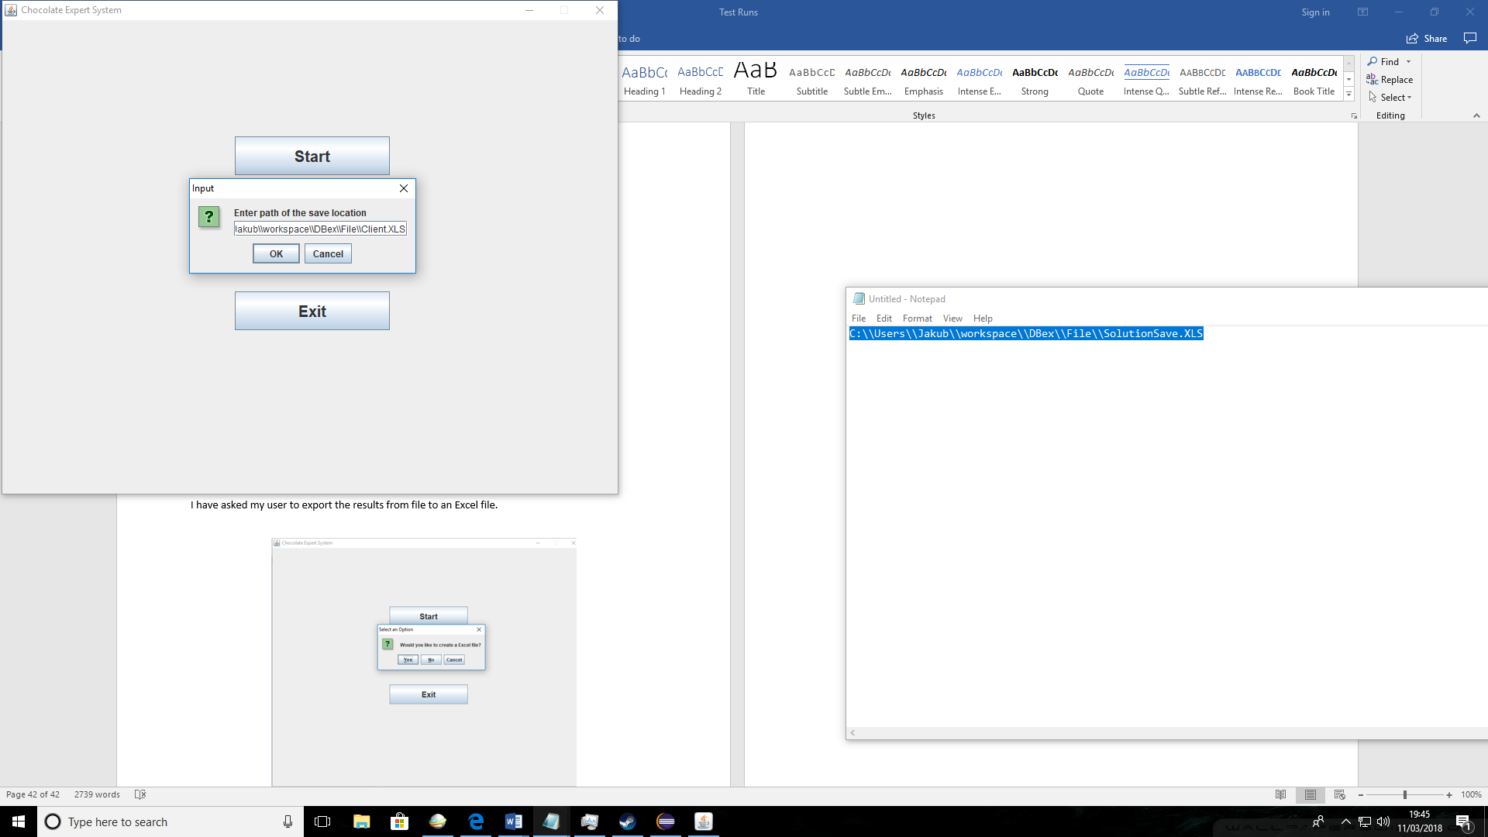

The file was saved to the given path

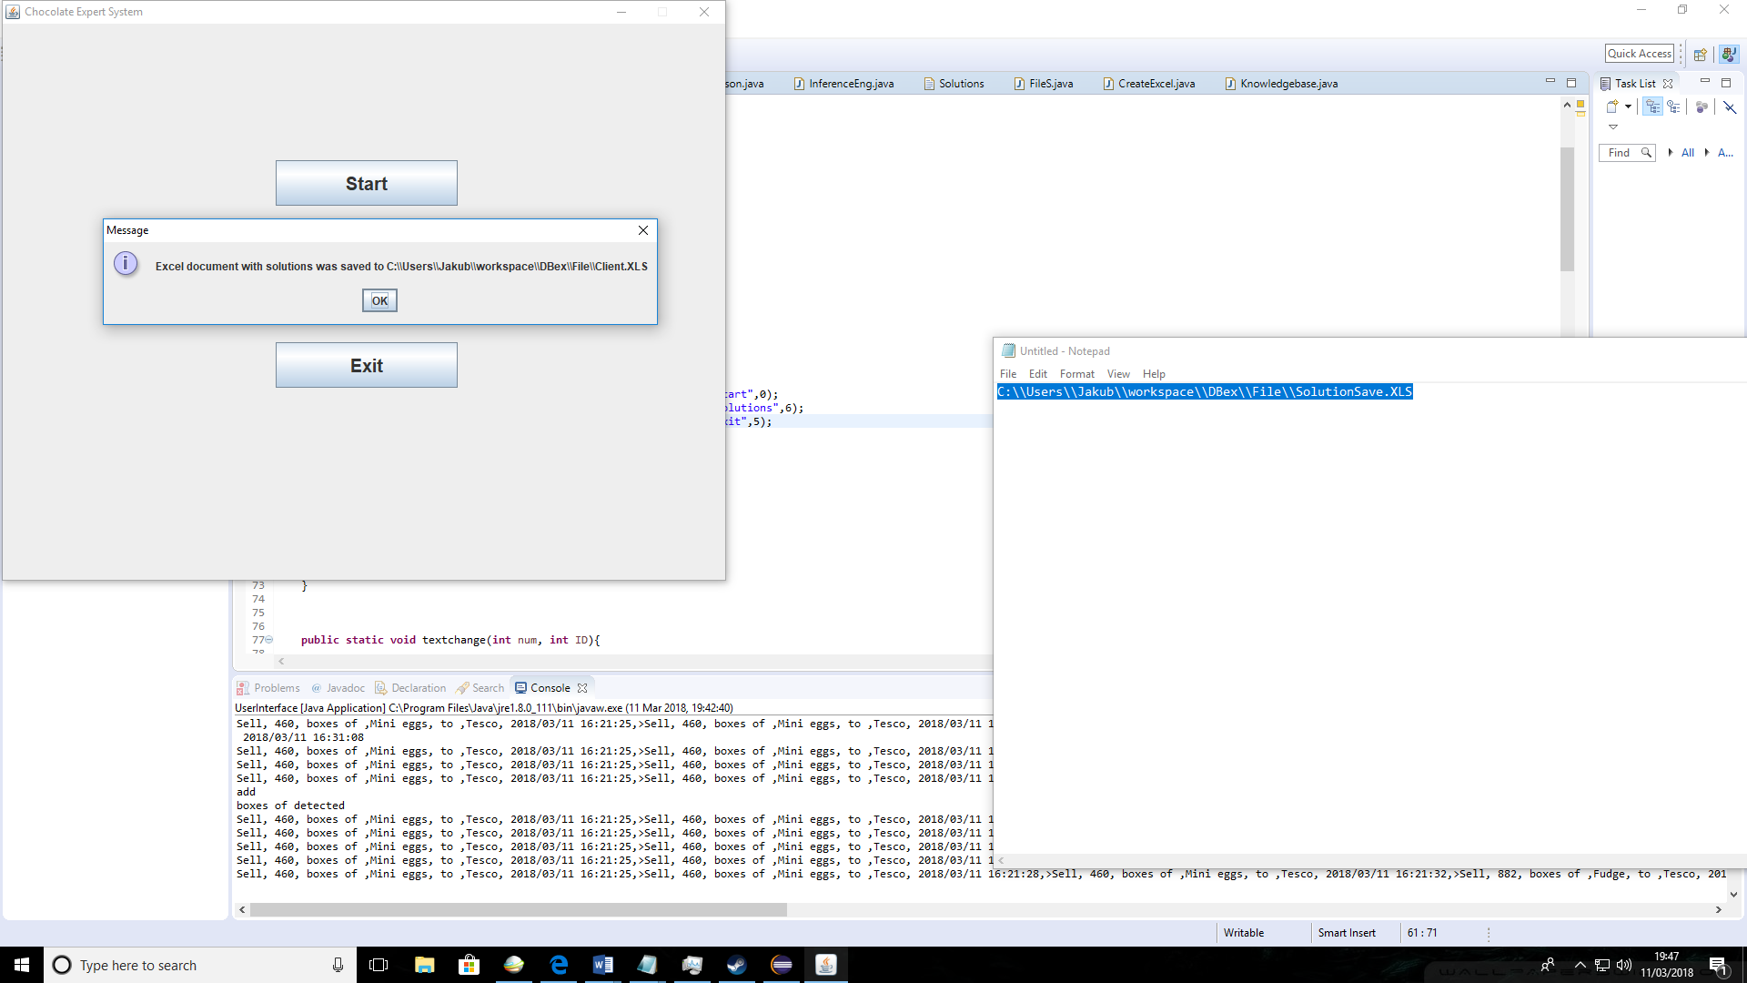

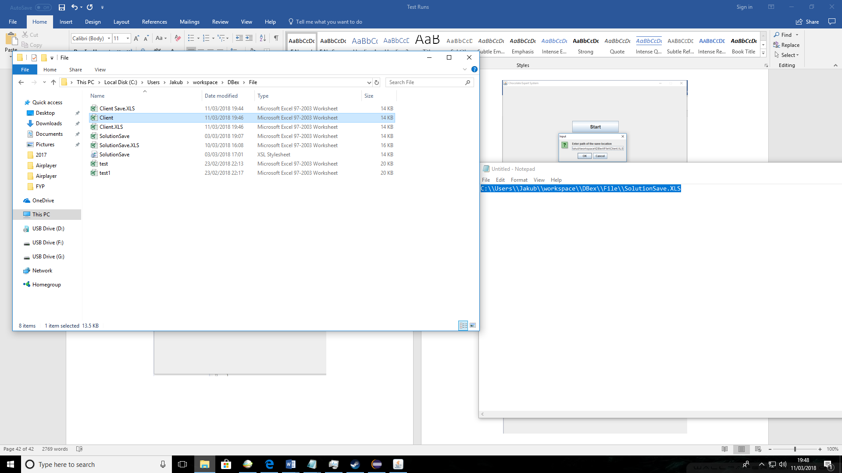The save location was checked and the saved file was there

